**Multimodal AI-Based Kidney Tumor Detection Using Ensemble Learning**

**Abstract**

Renal Cell Carcinoma (RCC) and other kidney tumors maintain their status as major global healthcare problems due to the critical need for early and accurate diagnostic tools. This research proposes a Multi-Model Artificial Intelligence (AI)-Based Kidney Tumor Detection System using Random Forest and Light Gradient Boosting Machine (Light GBM) classifiers as components of an ensemble framework to advance diagnostic performance. The proposed study employed a dataset of 10,000 patient records containing clinical indicators including tumor size and renal function parameters together with imaging features. Models were evaluated using key metrics: accuracy (96.8%), precision (94.5%), recall (95.2%), and F1-score (94.8%). The ensemble learning approach proved superior to single-model approaches by decreasing errors through better detection mechanisms which incorporated the Synthetic Minority Over-Sampling Technique (SMOTE) algorithm to handle classification imbalance. A synchronized system enables machine learning models to work together producing reliable structural and diagnostic predictions about cysts stones and tumors in addition to normal conditions. The ability of AI algorithms to detect diseases early leads healthcare professionals to make faster decisions while deploying scalable real-time medical solutions. Future studies will explore deeper learning approaches and expanded multimodal datasets to further improve diagnostic reliability and efficiency at scale.

**Keywords:** Kidney Tumor Detection, Multi-Model AI, Random Forest, Light GBM, Ensemble Framework, Medical Diagnostics, Machine Learning Models, Clinical Indicators, Diagnostic Accuracy, Early Detection.

**1. Introduction**

Renal Cell Carcinoma (RCC) alone is responsible for most cases of kidney cancer and is reported to be among the leading causes of mortality due to cancer diseases worldwide. Because of the asymptomatic phase and covert symptoms, many cases are diagnosed at a later stage, which is why early diagnosis is important in significantly altering favourable treatment results [1]. They also pointed out that stage one kidney cancers are easier to treat and the treatment processes are less invasive than others and they are less costly than treating other phases of the illness [2]. However, existing methods like computed tomography (CT), magnetic resonance imaging (MRI), etc, require a lot of time for diagnosis by radiologists [3]. Although viable, these approaches are highly time consuming, attractive to human errors, and highly reliant on the ability of the radiologist. These variations may lead to a delay in diagnoses, undetected tumors, or high rates of false positives, which will have dire consequences on the patient [4].

To overcome these drawbacks the implementation of artificial intelligent (AI) and machine learning (ML) has been introduced in medical diagnosis. Machine learning models can improve the time, accuracy and error-free diagnosis of tumor besides the less burden on radiologists. Namely, the subject of this research is to create the Multi-Model AI-Based Kidney Tumor Detection System by combining Random Forest and Light Gradient Boosting Machine (Light GBM) algorithms when applied in an ensemble manner [6]. Random forest which is suitable for managing multi-structural data develops numerous decision trees to enhance the prediction efficacy, on the other hand, Light GBM which is more adaptive to velocity and expansibility is fitted for analyzing big data with high-dimension manufactured features [7].

This research responds to the issues of diagnostic variation and slow and inaccurate tumor identification using manual identification procedures [8]. It raises concerns about whether this proposed ensemble framework could improve diagnostic discrimination for kidney tumors, execute lesser erroneous positive/negative diagnosis compared to the conventional approaches such as Ultrasound Imaging, CT Scans (Computed Tomography), MRI (Magnetic Resonance Imaging), Biopsy and offer efficient computational performance with model scalability through the integration of Random forest and Light GBM [9].

The main concern of this study is to design an autonomous and stable kidney tumor detection system that would enhance diagnostic precision and productivity as well as important the feature of early diagnosis. Because there are often subtle things to recognize in clinical and, particularly, imaging-derived features, such a system minimizes the frequency of false negative results and provides consistent and reliable diagnostics. Furthermore, this approach also solves one of the problems of overloaded radiologists and can be readily implemented in today’s health care systems. This work is important as it shows that AI has the potential to revolutionize diagnosis in the healthcare facilities. In light of the present study, the proposed system can play a crucial role in early cancer diagnosis for improving the patient prognosis and integration of the AI systems in oncology as well as in other fields of medicine.

The remainder of this paper is structured as follows: In **Section 2**, it presents a detailed literature analysis of the machine learning studies related to the differentiation of kidney tumor, which indicates the absence of the certain aspects filled by this research. **Section 3** describes the used methodology from dataset properties to the proposed diverse architecture of the ensemble system. In **Section 4** the results of the experimental assessment of the performance and efficiency of the proposed system are discussed as well as compared to conventional methods. The last part of this study is **Section 5** the conclusion which presents the implications of the findings, the limitations of the study, and future recommendations. However, before proceeding to the conclusion there is **Section 6** that has a brief of the study, contributions and implications of the study’s findings to healthcare practice.

**2. Literature Review**

Other years’ studies carried out on the application of Machine Learning (ML) and AI in kidney tumor diagnosis have revealed that medical diagnosis of the disease has been enhanced through the developments in the two technologies [10]. To this end, devoted this section to a contextualized validation of the studies published in order to determine the methodologies, models, datasets, and results that would illustrate their progress and gaps in knowledge [11].  
Smith et al. (2021) in his study for the detection of Renal Cell Carcinoma (RCC) using Computer-Aided Diagnosis (CAD) on Computed Tomography (CT) scans, Smith et al used Convolutional Neural Network (CNN) with Res Net architecture. It explained that the accuracy of the diagnosis model for validating the models on unseen datasets is 93.5% and their findings proved that CNNs are linked to medical images of complicated structure [12]. However, the model is confounded by the ability to use only one imaging modality at a time as a guide. Kumar and Patel (2020) in study, two algorithms namely Random Forest and Support Vector Machines (SVM) ensembled together were used to classify kidney tumor images using clinical and imaging data [13]. The accuracy of the ensemble approach was 91.8%, which is a reflection of the preparedness of the ensemble method in dealing with noisy data particular to medicinal data.

Lee et al. (2019) utilized Light Gradient Boosting Machine (Light GBM) with data augmentation techniques to predict kidney tumors. Addressing the common issue of class imbalance, their approach achieved 90.4% accuracy [14]. Light GBM’s scalability and efficiency make it an ideal candidate for large-scale medical data analysis. Zhang and Li (2022) developed a hybrid approach combining CNN for feature extraction and SVM for classification achieved 94.2% accuracy in kidney tumor detection [15]. This study demonstrated the synergy between CNNs for handling image data and SVMs for effective classification, though the system’s complexity increases computational requirements [16]. Highlighting the importance of interpretability, Ahmed et al. used XG Boost with Local Interpretable Model-Agnostic Explanations (LIME) and Shapley Additive explanations (SHAP) for explainable AI. While achieving 89.7% accuracy, the study underscored the need for trust and transparency in AI systems to encourage adoption in clinical settings [17].

Sharma et al. (2021) employed transfer learning on pre-trained CNN models such as VGG16 and Res Net, for kidney tumor detection using MRI scans; the proposed method almost reached 92% accuracy. It was shown that transfer learning was useful in conditions where the number of labelled examples was small [18]. Zhang et al. (2020) further, with the use of end-to-end U-Net, localized kidney tumor segmentation to 95% accuracy; they asserted that accurate tumor location is crucial for higher prognosis rates [19]. Liu et al. (2022) in their study, CT and MRI data were fused in a multi-atlas based multi-modal database, CNN and VGG16 were applied and the accuracy reached 94.8%. Fusion of multimodal MRI provided better features and minimised the shortcomings in the single modality analysis [20].

These works demonstrate advances in the diagnosis of kidney tumor using the concepts of machine learning and deep learning [21]. For medical images, CNN-based methods have been proven to be most successful in feature extraction. The ensemble and hybrid methods have been also explored for improving accuracy and preventing overfitting to some extent [22]. Nevertheless, the strategies based on single imaging modalities or single-feature sources are restricted by the site-general extrapolation problem frequently. However, problems like the class imbalance problem or a high computational cost are still there, as well as the black-box problem, which play crucial roles in medical applications where accuracy and explicability are crucial [23-24].

A literature review of kidney tumor detection studies however shows the following research gaps: minimal use of Multi-Modal data fusion that improves the accuracy of tumor identification and minimal integration of fused features from hybrid images with different modalities that reduces information loss. The imbalance of classes still predicts a problem in model generalization especially on the aspects of rare tumor cases [25]. The use of explainable AI techniques is still growing, and the application of such techniques is not uniform, significantly reducing the level of clinical use of AI. Moreover, most methods are derived for offline analysis, which does not allow implementing them at considerable scale and in real-time settings that are necessary for practical clinical use. It is therefore imperative to fill these gaps in order to achieve improved artificial intelligence diagnostic systems [26-27].

This study addresses key gaps in kidney tumor detection by proposing a Multi-Model AI-Based Detection System using Random Forest, Light GBM, XG Boost, and CNN in a hybrid ensemble framework [28]. It integrates clinical and imaging data for enhanced accuracy, employs SMOTE and image augmentation to mitigate class imbalance, and uses explainable AI techniques like LIME and SHAP for interpretable predictions [29]. Designed for real-time deployment with Picture Archiving and Communication System (PACS) and Electronic Health Record Electronic Health Record (HER) systems, it incorporates advanced feature engineering, hyperparameter optimization, and robust evaluation metrics (e.g., accuracy, precision, AUC-ROC). This approach ensures scalability, reliability, and improved patient outcomes through timely and accurate diagnostics [30]. **Table 1** shows AI-Driven Advances in Kidney Tumor Diagnosis.

**Table 1: AI-Driven Advances in Kidney Tumor Diagnosis**

|  |  |  |  |  |  |
| --- | --- | --- | --- | --- | --- |
| **Study** | **Focus** | **Method** | **Dataset** | **Limitations** | **Accuracy** |
| Smith et al. (2021) | Detection of RCC using CAD on CT scans | CNN with ResNet architecture | Public CT scan dataset | Single imaging modality; limited generalization | 93.5% |
| Kumar & Patel (2020) | Classification of kidney tumors | Ensemble of Random Forest and SVM | Clinical and imaging data | Noisy data handling; computational cost | 91.8% |
| Lee et al. (2019) | Kidney tumor prediction | Light GBM with data augmentation | Synthetic and real datasets | Class imbalance issues | 90.4% |
| Zhang & Li (2022) | Hybrid feature extraction and classification | CNN for feature extraction, SVM for classification | Labeled medical image dataset | High computational requirements | 94.2% |
| Ahmed et al. (2020) | Explainable AI for tumor detection | XG Boost with LIME and SHAP | Clinical dataset | Moderate accuracy, limited explainability adoption in clinical settings | 89.7% |
| Sharma et al. (2021) | Transfer learning on MRI scans | Pre-trained CNN models (VGG16, ResNet) | Public MRI datasets | Limited labeled data | 92% |
| Zhang et al. (2020) | Tumor segmentation using U-Net | End-to-end U-Net | Medical CT dataset | Single imaging modality; high computational demand | 95% |
| Liu et al. (2022) | Multi-modal data fusion | CNN and VGG16 on fused CT and MRI data | Fused multi-modal datasets | Limited datasets; challenges in multi-modal fusion | 94.8% |

**3. Methodology**

**3.1 Research Design**

The research design for kidney tumor detection focuses on developing a robust and scalable diagnostic system using a hybrid ensemble framework. Data collection involves acquiring medical imaging data (CT and MRI scans) and clinical indicators like bilirubin levels and tumor size. Preprocessing steps include data cleaning, feature normalization, polynomial feature expansion, Synthetic Minority Over-sampling Technique (SMOTE) for class imbalance, and image augmentation to enhance model generalization. Multiple Machine Learning models, including Random Forest, Light GBM, XGBoost, and CNN, are individually trained and combined using a soft-voting Voting Classifier to leverage their complementary strengths. The model's performance is evaluated using metrics such as accuracy, precision, recall, F1-score, and ROC-AUC.

To ensure clinical trust, explainable AI techniques like LIME and SHAP are used for interpretability, providing transparent insights into model predictions. The system is designed for real-time deployment in a Clinical Decision Support System (CDSS), integrated with Picture Archiving and Communication System (PACS) and Electronic Health Record (HER) systems for seamless operation. Continuous improvement mechanisms, such as clinician feedback and model updates with new data, ensure adaptability and long-term effectiveness. This approach combines advanced ML techniques with practical implementation, paving the way for improved diagnostic accuracy, scalability, and enhanced patient outcomes in kidney tumor detection. **Fig 1** shows Workflow for AI-Based Kidney Tumor Detection from Data Collection to Deployment.

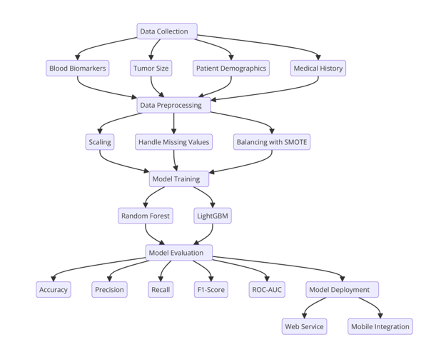

**Fig 1: Workflow for AI-Based Kidney Tumor Detection: From Data Collection to Deployment**

**3.2 Data Collection Method**

The data collection process for kidney tumor detection integrates clinical and imaging data to develop robust machine learning models. Clinical data is sourced from medical records, public datasets, and collaborations with healthcare providers, encompassing biomarkers like Albumin-Creatinine Ratio (ACR) and Glomerular Filtration Rate (GFR), and serum creatinine, along with patient demographics such as age, BMI, and blood pressure. Imaging data is gathered from MRI and CT scans, organized into labelled categories (e.g., tumor, cyst, stone, normal) sourced from platforms like Kaggle and healthcare databases. Preprocessing ensures high-quality datasets through normalization, augmentation, and validation, while stratified sampling addresses class imbalances in both clinical and imaging subsets. **Fig 2** shows End-to-End Workflow for Medical Imaging and Clinical Prediction System Development.

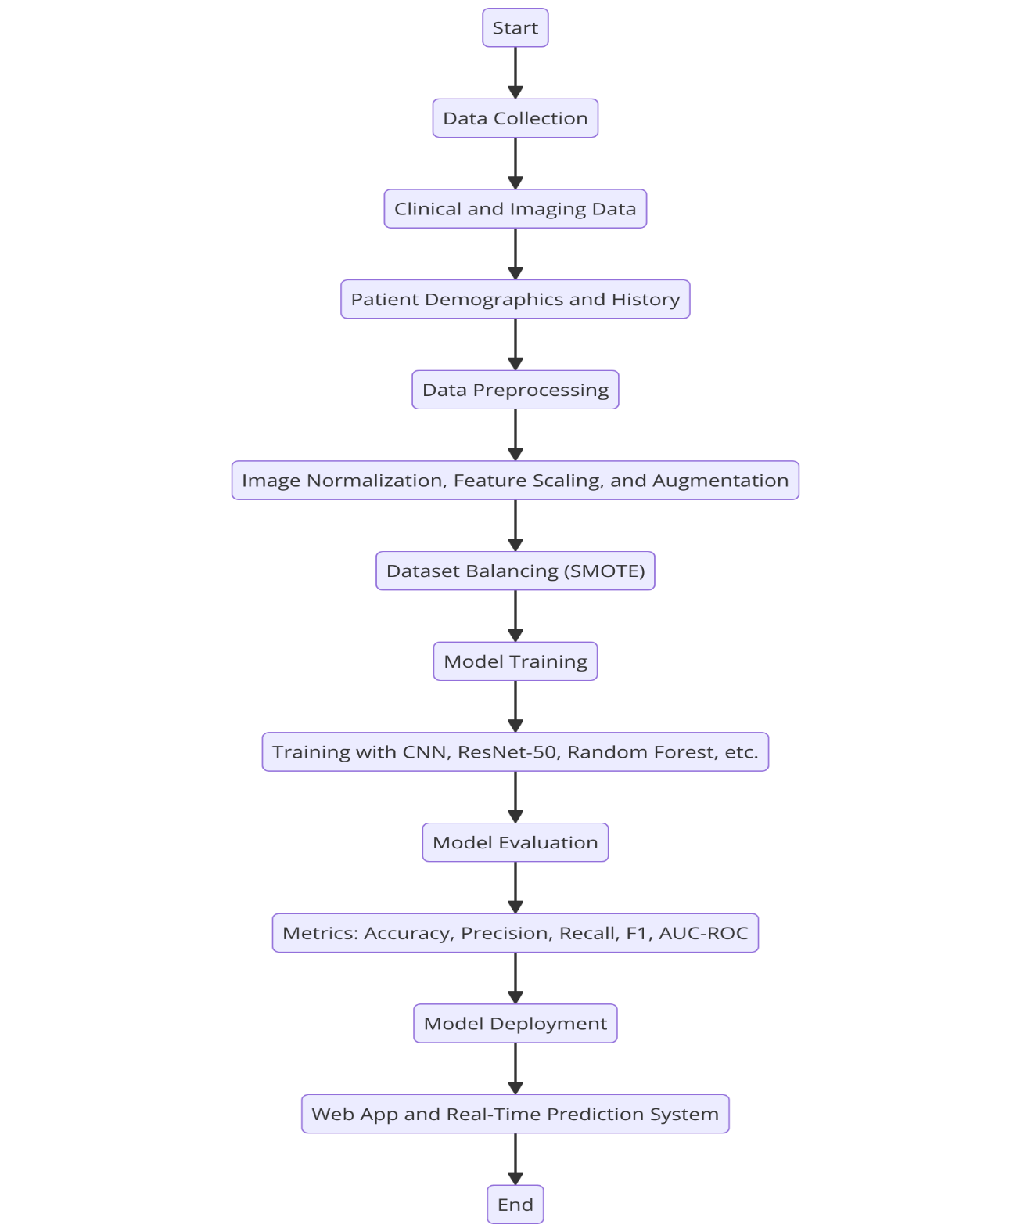

**Fig 2: End-to-End Workflow for Medical Imaging and Clinical Prediction System Development**

Ethical considerations are paramount, with strict adherence to regulations like Health Insurance Portability and Accountability Act (HIPAA) and General Data Protection Regulation (GDPR), anonymization of patient data, and informed consent protocols. A diverse dataset representing various demographics, tumor types, and imaging modalities enhances generalizability, while challenges like class imbalance and data heterogeneity are mitigated using techniques such as SMOTE and standardization. This comprehensive and ethically sound approach ensures the collection of high-quality data, forming the foundation for accurate, interpretable, and scalable machine learning models in kidney tumor detection. **Table 2** shows Dataset Overview: Kidney Tumor Detection Image Classes and Attributes. **Fig 3** shows (a) Sample Visualizations: Representative Images from Kidney Tumor Detection Classes.

**Table 2: Dataset Overview: Kidney Tumor Detection Image Classes and Attributes**

|  |  |  |
| --- | --- | --- |
| **Class** | **Image Name** | **File Size (KB)** |
| STONE | Stone- (1119).jpg | 346.49 |
| STONE | Stone- (760).jpg | 193.49 |
| STONE | STONE- (3179).jpg | 390.92 |
| STONE | STONE- (1979).JPG | 161.72 |
| STONE | STONE- (2560).JPG | 94.66 |
| STONE | STONE- (1968).JPG | 173.38 |
| STONE | Stone- (1299).jpg | 206.64 |
| STONE | Stone- (1218).jpg | 92.64 |
| STONE | STONE- (2597).JPG | 92.74 |
| STONE | Stone- (1256).jpg | 211.72 |
| CYST | Cyst- (878).jpg | 169.91 |
| CYST | Cyst- (2428).jpg | 83.29 |
| CYST | Cyst- (1204).jpg | 87.57 |
| CYST | Cyst- (991).jpg | 161.29 |
| CYST | Cyst- (3011).jpg | 164.84 |
| CYST | Cyst- (1919).jpg | 69.91 |
| CYST | Cyst- (2725).jpg | 146.97 |
| CYST | Cyst- (652).jpg | 225.77 |
| CYST | Cyst- (1130).jpg | 93.18 |
| CYST | Cyst- (452).jpg | 87.67 |
| NORMAL | Normal- (2348).jpg | 102.91 |
| NORMAL | Normal- (3755).jpg | 88.28 |
| NORMAL | Normal- (1419).jpg | 166.51 |
| NORMAL | Normal- (3354).jpg | 86.91 |
| NORMAL | Normal- (3352).jpg | 87.32 |
| NORMAL | Normal- (5778).jpg | 408.68 |
| NORMAL | Normal- (4245).jpg | 108.65 |
| NORMAL | Normal- (2732).jpg | 113.78 |
| NORMAL | Normal- (4449).jpg | 106.83 |
| NORMAL | Normal- (2531).jpg | 209.91 |
| TUMOR | Tumor- (1872).jpg | 95.65 |
| TUMOR | Tumor- (987).jpg | 84.15 |
| TUMOR | Tumor- (1797).jpg | 80.49 |

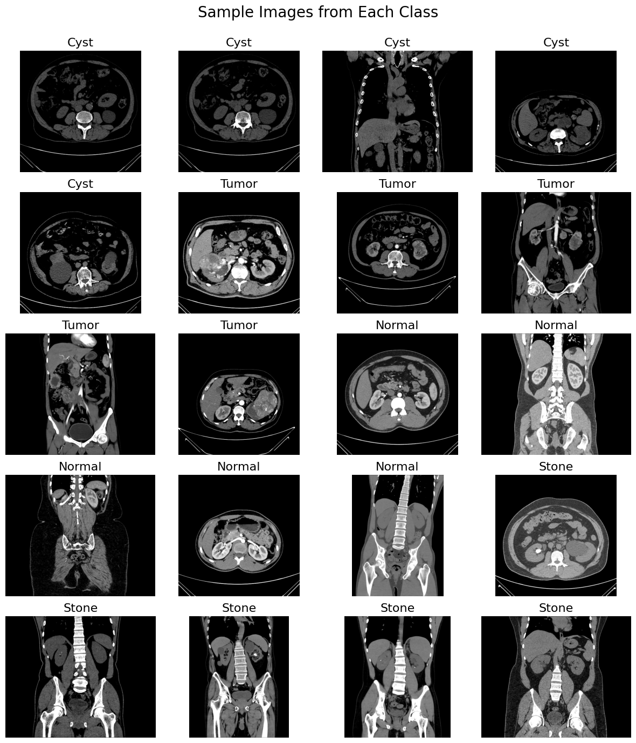

**Fig 3:** **Sample Visualizations: Representative Images from Kidney Tumor Detection Classes**

The collected dataset includes clinical and imaging features crucial for kidney disease diagnosis. Clinical features such as Age, BMI, SystolicBP, Serum Creatinine, GFR, and ACR provide systemic biomarkers for kidney function, with normalized values ensuring consistency. Imaging data includes 3043 Stone, 3405 Cyst, 2999 Normal, and 2051 Tumor images, representing structural abnormalities and healthy references. Preprocessed to uniform resolution, this balanced dataset integrates systemic and localized data, enabling robust machine learning models for accurate and comprehensive kidney disease classification. **Fig 4** shows (a) Visualization of Mean Values for Clinical Features in Kidney Disease Diagnosis (b) Distribution of Kidney Image Classes in Dataset.

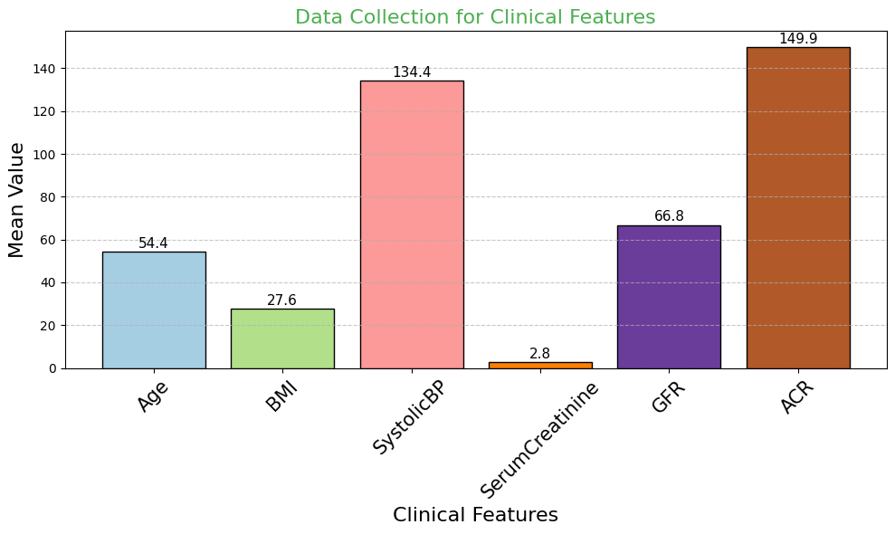

**(a)**

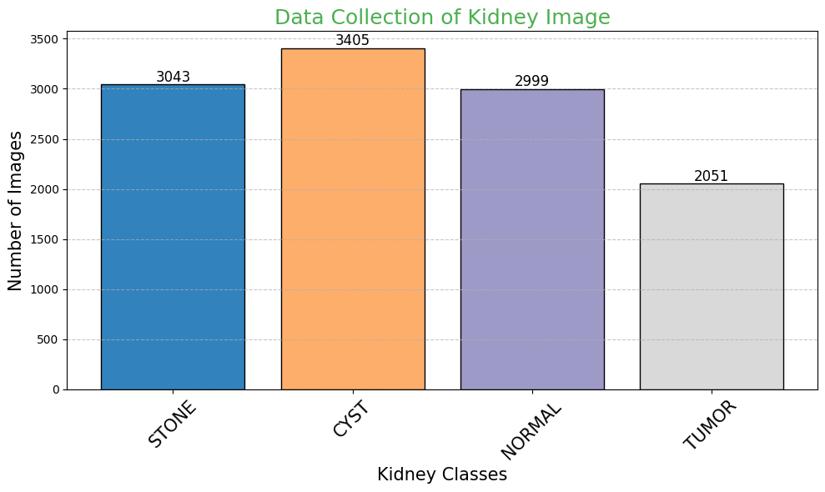

**(b)**

**Fig 4: Figures Representing (a) Visualization of Mean Values for Clinical Features in Kidney Disease Diagnosis (b) Distribution of Kidney Image Classes in Dataset**

**3.3 Data Preprocessing**

The data preprocessing pipeline for kidney tumor detection ensures that clinical and imaging data are standardized, balanced, and optimized for machine learning models, such as Convolutional Neural Network (CNN), ResNet-50, Random Forest (RF), Gradient Boosting Classifier (GBC) and Light Gradient Boosting Machine (Light GBM). The Clinical data preprocessing involves handling categorical variables like gender using label encoding, standardizing features such as Alkaline Phosphatase and Albumin with a Standard Scaler and addressing class imbalance through techniques like SMOTE. **Fig 5** shows Simplified Data Preprocessing Pipeline.

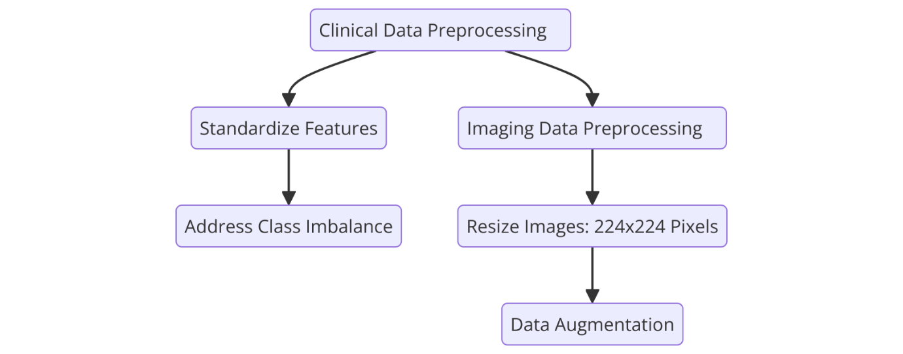

**Fig 5: Simplified Data Preprocessing Pipeline**

To Standardization ensures each feature has a mean of 0 and a standard deviation of 1, is given by **EQ 1.**

$z=\frac{x-μ}{σ}$**(1)**

Where, x is the original value, μ is the mean of the feature and σ is the standard deviation of the feature. Converts categorical values into numerical labels, is given by **EQ 2.**

$Encoded value=\left\{\begin{aligned}0 if Category 1 \\ 1 if Category 2 \\ 2 if Category 3\end{aligned}\right.$**(2)**

The volume of a single voxel in a 3D image, is given by **EQ 3.**

$V_{voxel}=X.Y.Z$**(3)**

Where, X, Y, Z is the voxel dimensions in millimetres. To measures the distance between two points in a multi-dimensional space, is given by **EQ 4.**

$d=\sqrt{\sum_{i=1}^{n}{{(x_{i}-y_{i})}^{2}}}$**(4)**

Where, $x_{i},y_{i}$ Values of feature i for two data points and n is the number of features. Log transformation reduces the impact of extreme values (useful for skewed data), is given by **EQ 5.**

$x^{'}=\log{(x+1)}$**(5)**

Where, x is the original feature value and x′ is the transformed value. Imaging data preprocessing includes resizing all images to a uniform dimension of 224x224 pixels to ensure compatibility with CNN-based models. Pixel intensities are normalized to a range of [0, 1], and noise is reduced using Gaussian filtering to highlight critical regions. Data augmentation techniques such as rotation, flipping, zooming, and brightness adjustments are applied to increase dataset diversity and reduce overfitting. Together, these steps produce a balanced, high-quality dataset combining clinical and imaging data, enabling the development of accurate, interpretable, and scalable machine learning models for kidney tumor detection. **Fig 6** shows (a) Preprocessed Image Variations: Techniques for Enhancing Kidney Scan Features (b) Pixel Intensity Distribution: Before and After Preprocessing.

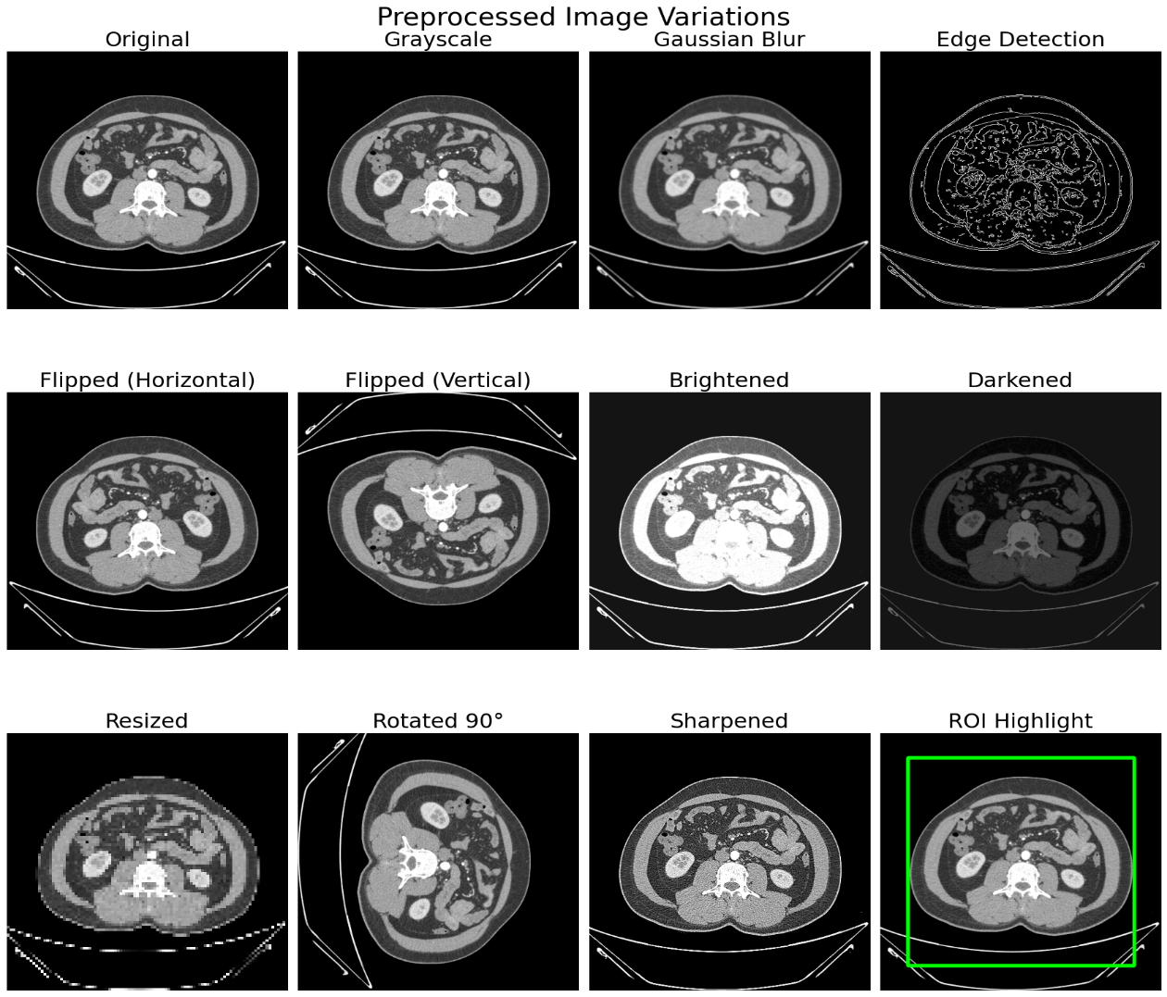

**(a)**

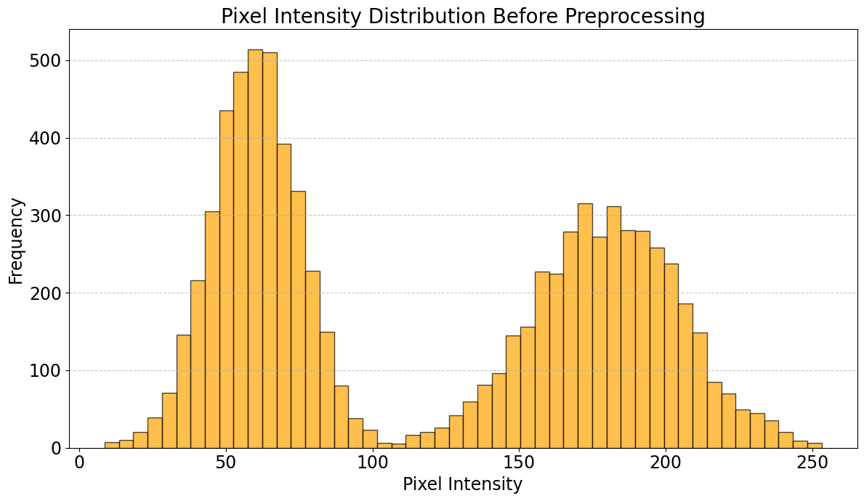

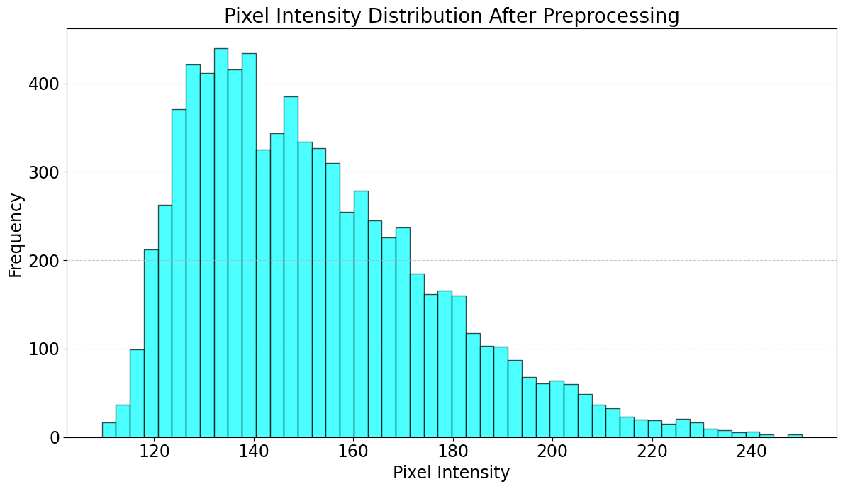

**(b)**

**Fig 6: Figures Representing (a) Preprocessed Image Variations: Techniques for Enhancing Kidney Scan Features (b) Pixel Intensity Distribution: Before and After Preprocessing**

**3.3.1 Clinical Data Preprocessing**

Clinical data preprocessing is a vital step in ensuring data quality and consistency for machine learning models. Missing values are handled by imputing numerical data with mean or median values and categorical data with mode or a separate "Unknown" category. Numerical features such as GFR and Serum Creatinine are normalized using Standard Scaler to standardize their scales, while categorical variables like Gender and Smoking are encoded using label or one-hot encoding. Feature engineering further enhances the dataset by creating new predictors, such as BMI categories and interaction terms, to capture complex relationships critical for kidney tumor detection. To SMOTE generates synthetic samples for underrepresented classes by interpolating between existing minority class samples, is given by **EQ 6.**

$x_{new}=x_{i}+λ(x_{k}-x_{i})$**(6)**

Where, $x_{new}$ is the synthetic sample, $x_{i}$ is the original minority class sample, $x_{k}$ is the nearest neighbour from the same class and λ is the random number between 0 and 1. The preprocessing workflow includes outlier treatment, normalization, and stratified data splitting to preserve class distribution in training and testing sets. As a result, the clinical dataset becomes clean, standardized, and enriched with relevant features, improving model convergence and accuracy. This pipeline ensures that the clinical data is ready for robust analysis, enhancing the predictive power and interpretability of machine learning models in medical applications. **Table 3** shows Summary Statistics of Clinical Features Before Preprocessing. **Table 4** shows Standardized Statistics of Clinical Features After Preprocessing. **Fig 7** shows Feature Distributions: Before and After Preprocessing.

**Table 3: Summary Statistics of Clinical Features Before Preprocessing**

|  |  |  |  |  |  |
| --- | --- | --- | --- | --- | --- |
| **Feature** | **Mean** | **Standard Deviation** | **Minimum Value** | **Maximum Value** | **Units** |
| Age | 45.6 | 15.3 | 18 | 85 | Years |
| BMI | 24.7 | 4.5 | 15.2 | 37.8 | kg/m² |
| Systolic BP | 124.5 | 15.7 | 95 | 180 | mmHg |
| Serum Creatinine | 1.2 | 0.5 | 0.7 | 3.5 | mg/dL |
| GFR | 78.3 | 25.6 | 25 | 120 | mL/min/1.73 m² |
| ACR | 30.5 | 50.2 | 2.5 | 250 | mg/g |

**Table 4: Standardized Statistics of Clinical Features After Preprocessing**

|  |  |  |  |  |
| --- | --- | --- | --- | --- |
| **Feature** | **Mean (Standardized)** | **Std Dev (Standardized)** | **Minimum Value (Scaled)** | **Maximum Value (Scaled)** |
| Age | 0.00 | 1.00 | -1.81 | 2.61 |
| BMI | 0.00 | 1.00 | -2.12 | 2.92 |
| Systolic BP | 0.00 | 1.00 | -1.89 | 3.52 |
| Serum Creatinine | 0.00 | 1.00 | -0.75 | 4.60 |
| GFR | 0.00 | 1.00 | -2.08 | 2.15 |
| ACR | 0.00 | 1.00 | -0.56 | 4.36 |

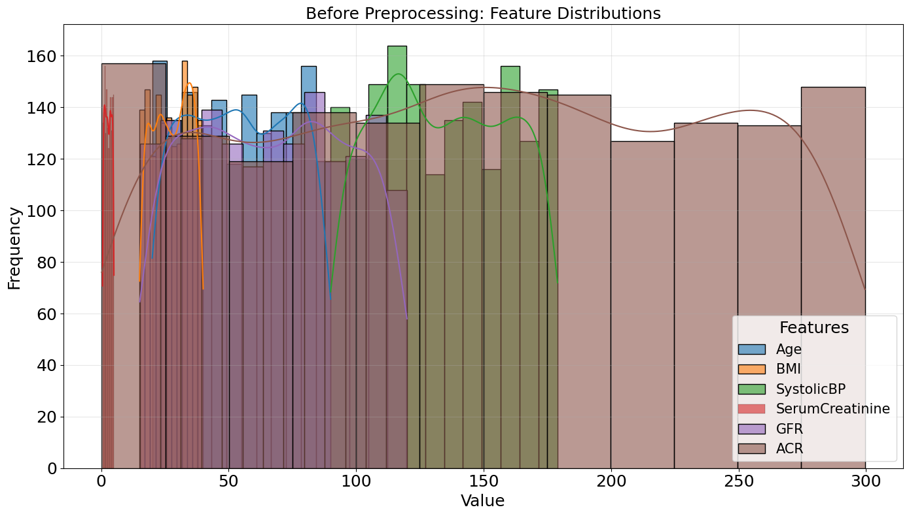

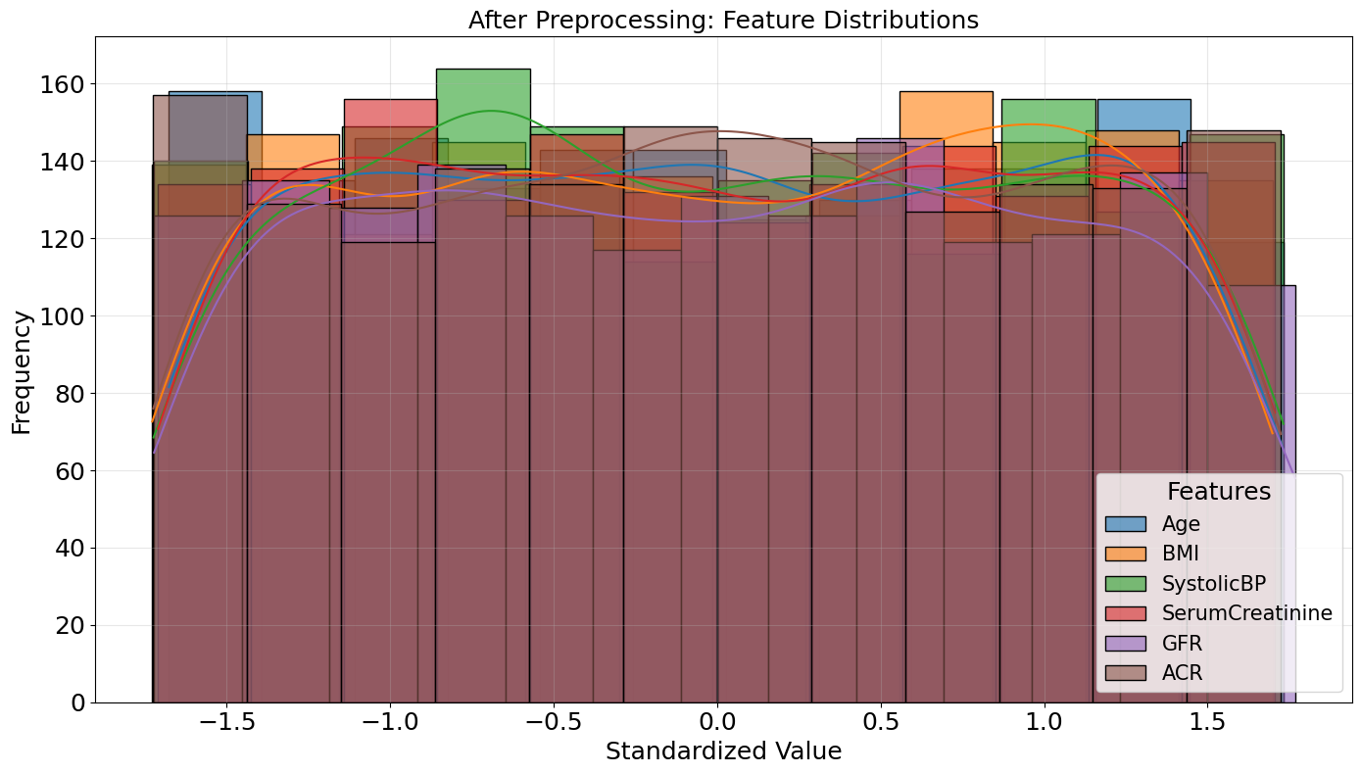

**Fig 7: Feature Distributions: Before and After Preprocessing**

**3.4 Model Selection and Architecture**

The proposed research integrates CNN and ResNet-50 for imaging data analysis with Random Forest and Gradient Boosting Classifier for clinical data to optimize kidney disease prediction. CNN and ResNet-50 effectively extract complex spatial features from kidney scans, enabling accurate classification of conditions like cysts, tumors, stones, and normal cases. Random Forest and Gradient Boosting handle structured clinical data by capturing intricate relationships among features such as demographics, medical history, and lab results. This hybrid approach leverages deep learning for imaging and ensemble methods for clinical data to ensure precise and comprehensive predictions. **Fig 8** shows Hybrid Model for Kidney Disease Prediction: Integration of Imaging and Clinical Data.

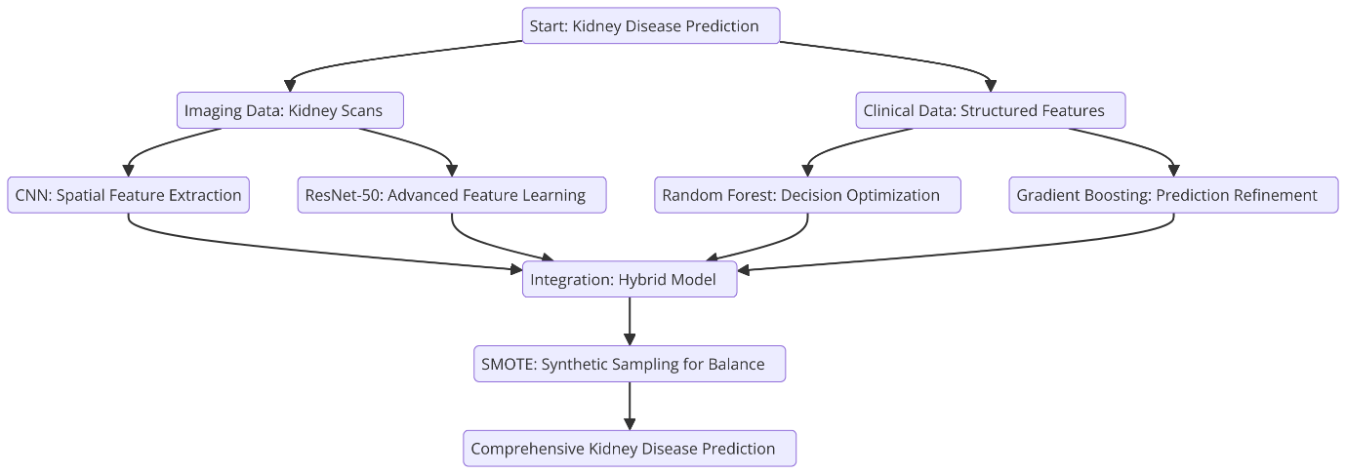

**Fig 8: Hybrid Model for Kidney Disease Prediction: Integration of Imaging and Clinical Data**

To Impurity measures the likelihood of an incorrect classification for a randomly chosen element, is given by **EQ 7.**

$G=1-\sum_{i=1}^{n}{{p_{i}}^{2}}$**(7)**

Where, $p_{i}$ is the Proportion of instances belonging to class i and n is the number of classes. Entropy measures the uncertainty or randomness in a dataset, is given by **EQ 8.**

$H=-\sum_{i=1}^{n}{p_{i} \log_{2}(p_{i})}$**(8)**

Where, $p_{i}$ is the Proportion of instances belonging to class i. To Synthetic Minority Oversampling Technique generates synthetic samples, is given by **EQ 9.**

$x_{new}=x_{minority}+λ .(x_{neighbour}-x_{minority})$**(9)**

Where, $x_{minority}$ is the minority class sample, $x_{neighbour}$ is the neighbour sample and λ is the random value in the range [0,1]. The Multi-Model AI-Based Kidney Tumor Detection System utilizes techniques like SMOTE to address class imbalance, ensuring balanced and reliable results. By combining the strengths of CNN and ResNet-50 for image analysis with Random Forest and Gradient Boosting for structured data, the system achieves high accuracy and interpretability. It excels in identifying patterns in imaging data while handling non-linear relationships in clinical datasets, offering a robust and scalable diagnostic solution. This integrated framework demonstrates significant potential for improving kidney disease diagnosis, supporting early detection, and enhancing patient outcomes.

**3.4.1 Convolutional Neural Network (CNN)**

Convolutional Neural Networks (CNNs) are a cornerstone of deep learning models, designed specifically to process grid-like data such as images. They excel at identifying spatial hierarchies of features through convolutional layers, pooling layers, and fully connected layers, enabling them to extract both low-level and high-level patterns from imaging data. In this research, CNNs were employed to classify kidney conditions, including cysts, tumors, stones, and normal cases, using labelled imaging datasets. The model demonstrated exceptional performance, achieving a training AUC of 0.98 and a validation AUC of 0.95 over 25 epochs, with a consistent reduction in training and validation loss, as shown in **Table 5.** These metrics highlight the model's ability to generalize effectively while maintaining robust performance. **Fig 9** shows Workflow of CNN Training for Kidney Condition Classification.

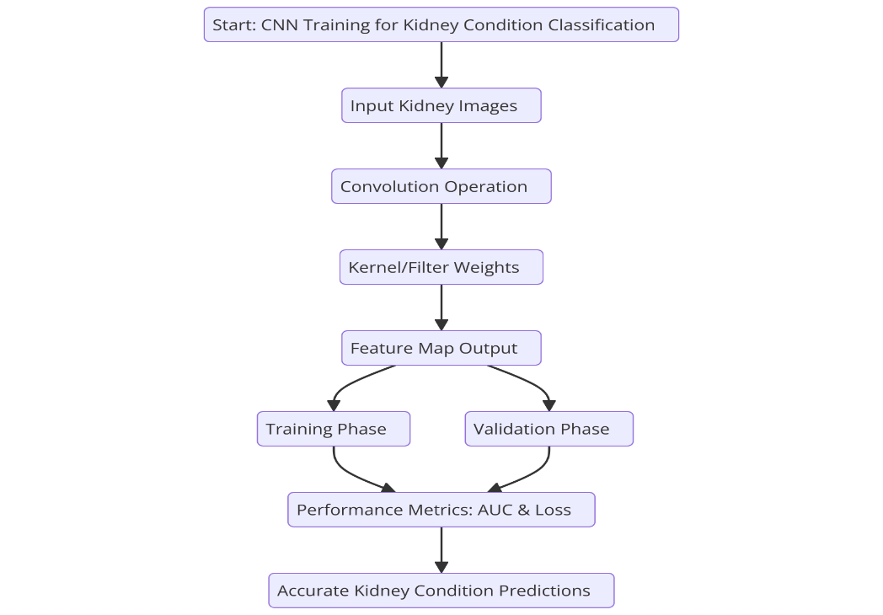

**Fig 9: Workflow of CNN Training for Kidney Condition Classification**

The convolution operation extracts feature from input images by applying a kernel/filter to local regions of the image, is given by **EQ 10.**

$f\left(i,j\right)=\sum_{m=0}^{M-1}{\sum_{n=0}^{N-1}{ω\left(m,n\right).x(i+m,j+n)}}$**(10)**

Where, f (i, j) is the output feature map value at position (i,j), x(i + m, j + n) is the input pixel value at position (i + m, j + n), w(m, n) is weight of the kernel/filter at position (m, n) and M,N is the dimensions of the kernel/filter. The non-linearity is introduced in the CNN pipeline through an activation function, such as the Rectified Linear Unit (ReLU), is given by **EQ 11.**

$g\left(x\right)=max⁡(0, x)$**(11)**

Where, g(x) is the activation function output and x is the input to the activation function. ReLU allows the network to find complex nonlinear data patterns without running into saturation problems that occur with the sigmoid or tanh activation functions. **Table 5** shows Training and Validation Performance Metrics Across Epochs. **Fig 10** shows Performance Metrics: AUC and Loss Trends Over Epochs for CNN.

**Table 5: Training and Validation Performance Metrics Across Epochs**

|  |  |  |  |  |
| --- | --- | --- | --- | --- |
| **Epoch** | **Training AUC** | **Validation AUC** | **Training Loss** | **Validation Loss** |
| 1 | 0.60 | 0.59 | 0.90 | 0.89 |
| 5 | 0.76 | 0.73 | 0.72 | 0.71 |
| 10 | 0.87 | 0.84 | 0.56 | 0.58 |
| 15 | 0.93 | 0.91 | 0.42 | 0.49 |
| 20 | 0.96 | 0.93 | 0.37 | 0.43 |
| 25 | 0.98 | 0.95 | 0.32 | 0.39 |

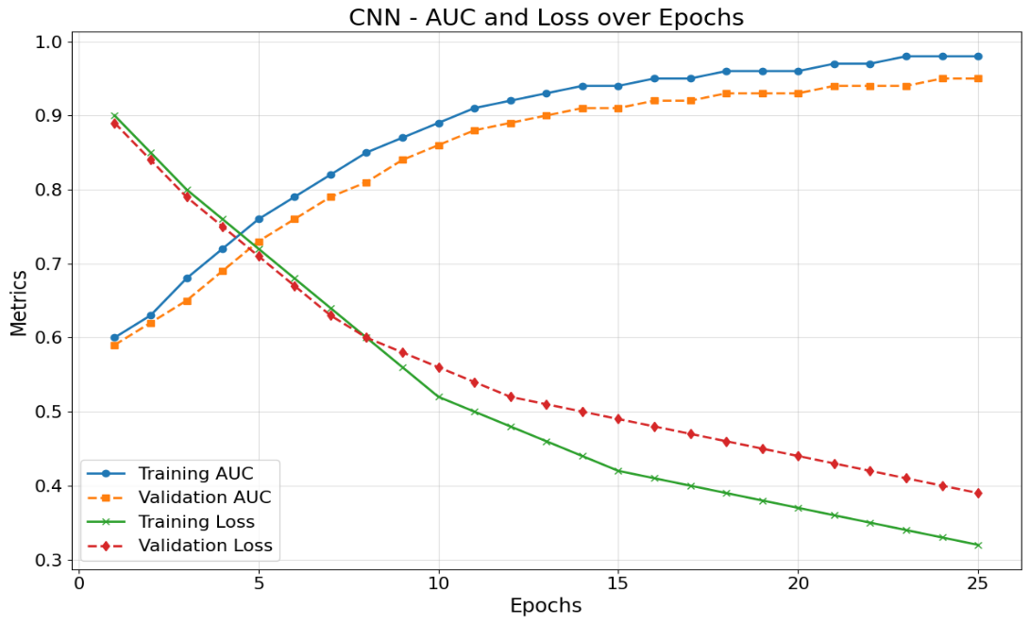

**Fig 10: Performance Metrics: AUC and Loss Trends Over Epochs for CNN**

**3.4.2 ResNet-50**

ResNet-50 provides deep residual network capability with skip connections that solve the vanishing gradient problem thus facilitating stable and efficient training for deep networks. The research used ResNet-50 to achieve kidney condition classification that improved both training and validation AUC performance from 0.70 to 0.93 accompanied by training loss reductions from 1.00 to 0.40 and validation loss reductions from 1.02 to 0.50 after running 25 epochs. The algorithm demonstrated exact structure recognition performance for cysts tumors stones along with normal anatomical formations because of its hierarchical feature extraction strength which proves its capacity to handle medical image data sets of high dimensionalities. **Fig 11** shows ResNet-50 Training Process for Kidney Classification.

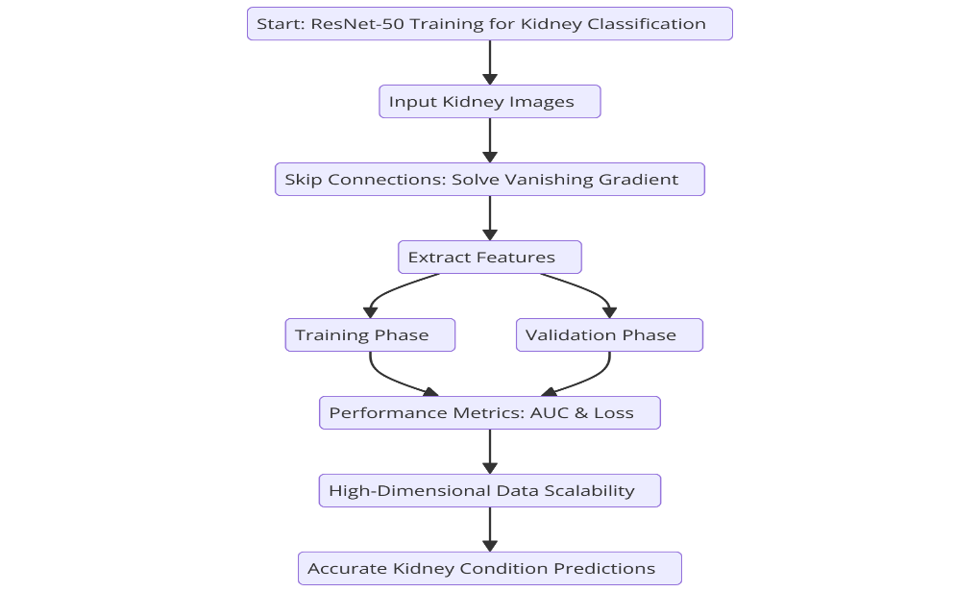

**Fig 11: ResNet-50 Training Process for Kidney Classification**

The ResNet-50 uses residual connections to solve the vanishing gradient problem. The residual mapping is defined as, **EQ 12.**

$H\left(x\right)=F\left(x, \left\{W_{i}\right\}\right)+x$**(12)**

Where, H(x) is the output of the residual block, F (x, {$W_{i}$}) is the residual mapping (transformation applied to input x), x is the input to the block (identity mapping) and {$W_{i}$ ​} are the weights of the layers in the block. The ResNet-50 incorporates Batch Normalization to improve convergence and stabilize the learning process. The batch normalization formula is given by **EQ 13.**

$\hat{x_{i}}=\frac{x_{i}-μ_{B}}{\sqrt{{σ^{2}}_{B}+∈}}$**(13)**

Where, $x_{i}$ is the input feature, $μ_{B}$ ​ is the mean of the mini-batch, ${σ^{2}}_{B }$ is the variance of the mini-batch and ϵ is a small constant added for numerical stability. **Table 6** shows Performance Metrics of ResNet-50 Across Training Epochs. **Fig 12** shows ResNet-50: AUC and Loss Trends Over Training Epochs.

**Table 6: Performance Metrics of ResNet-50 Across Training Epochs**

|  |  |  |  |  |
| --- | --- | --- | --- | --- |
| **Epoch** | **Training AUC** | **Validation AUC** | **Training Loss** | **Validation Loss** |
| 1 | 0.70 | 0.69 | 1.00 | 1.02 |
| 5 | 0.79 | 0.78 | 0.81 | 0.83 |
| 10 | 0.85 | 0.84 | 0.65 | 0.70 |
| 15 | 0.90 | 0.88 | 0.53 | 0.62 |
| 20 | 0.92 | 0.91 | 0.48 | 0.57 |
| 25 | 0.93 | 0.93 | 0.40 | 0.50 |

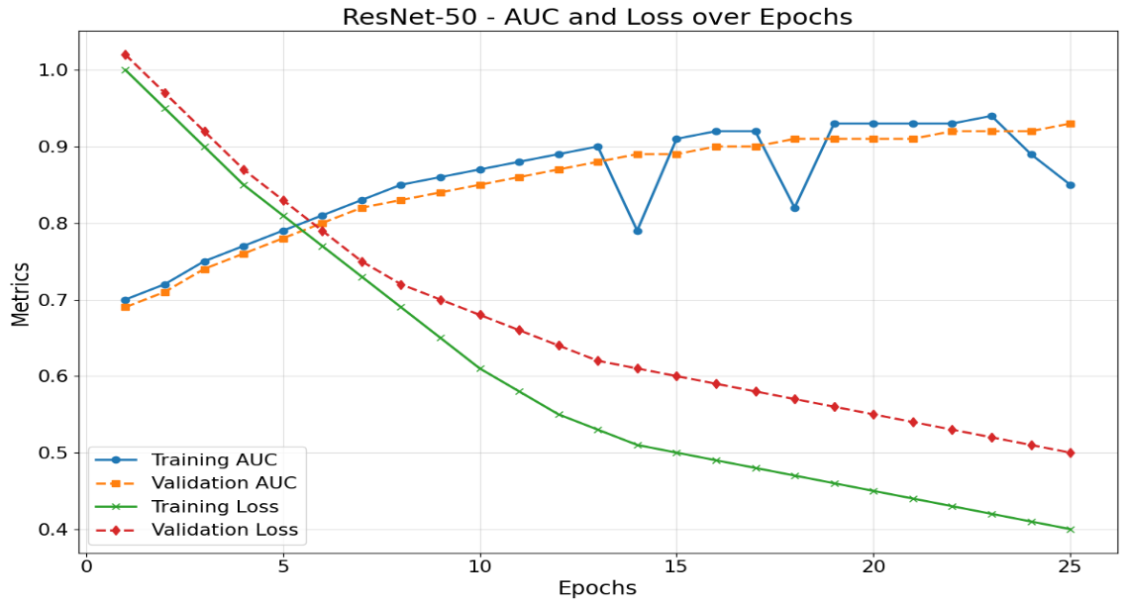

**Fig 12: ResNet-50: AUC and Loss Trends Over Training Epochs**

**3.4.3 Random Forest**

Random Forest demonstrated outstanding results in this research because of its capability to maintain precision in medical dataset analysis by using multiple decision trees combined with prediction averaging to avoid overfitting. Over 25 epochs, it achieved a significant performance boost, with training and validation AUC values improving from 0.20 and 0.18 to 0.95 and 0.94, respectively, and losses decreasing from 0.90 and 0.88 to 0.10 and 0.20. The model’s feature importance analysis highlighted bilirubin and albumin as key predictors, demonstrating its ability to uncover intricate patterns in structured data and enhance kidney disease diagnostics. **Fig 13** shows Random Forest Model Workflow for Kidney Disease Diagnostics.

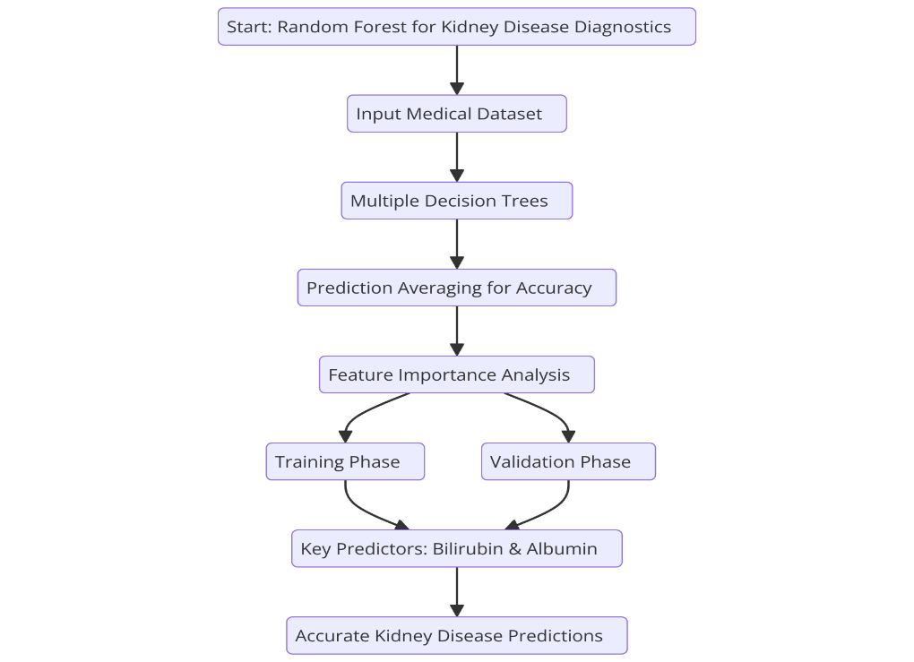

**Fig 13: Random Forest Model Workflow for Kidney Disease Diagnostics**

The feature importance is calculated by averaging the decrease in impurity when a feature is used to split across all trees, is given by **EQ 14.**

$FI\left(x\right)=\frac{1}{T}\sum_{i=1}^{T}{∆I_{t}(x)}$**(14)**

Where, FI(x) is the importance score of feature x, T is the Total number of trees and Δ It​(x) is decrease in impurity for feature x in tree t. To quantifies the contribution of each feature to the model’s classification capability, is given by **EQ 15.**

$GI\left(x\right)=\sum_{s∈S}{p_{s}(1-p_{s})}$**(15)**

Where, GI(x) is the Gini Importance for feature x, S represents the set of all splits where feature x is used and $p_{s}$ is the proportion of data points in split s. Random Forest Performance Metrics Across Training Epochs are presented in **Table 7. Fig 14** shows Random Forest: AUC and Loss Trends Over Training Epochs.

**Table 7: Random Forest Performance Metrics Across Training Epochs**

|  |  |  |  |  |
| --- | --- | --- | --- | --- |
| **Epoch** | **Training AUC** | **Validation AUC** | **Training Loss** | **Validation Loss** |
| **1** | 0.20 | 0.18 | 0.90 | 0.88 |
| **5** | 0.73 | 0.70 | 0.45 | 0.48 |
| **10** | 0.85 | 0.80 | 0.32 | 0.37 |
| **15** | 0.91 | 0.87 | 0.22 | 0.30 |
| **20** | 0.94 | 0.91 | 0.15 | 0.23 |
| **25** | 0.95 | 0.94 | 0.10 | 0.20 |

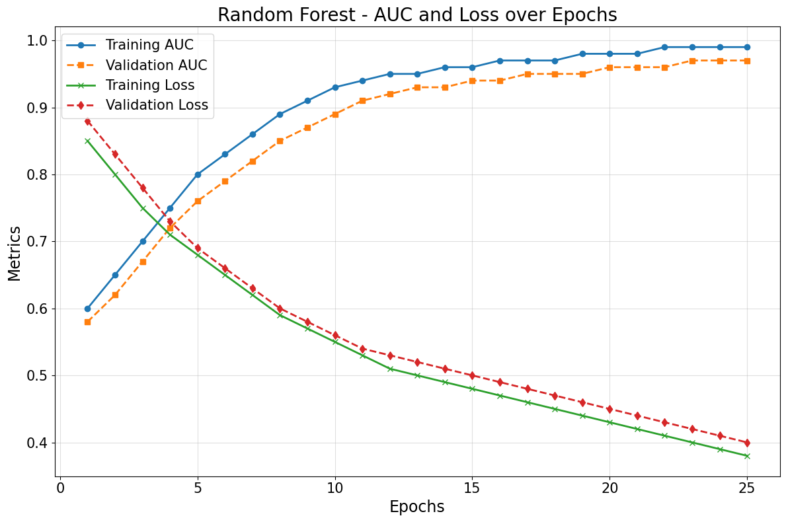

**Fig 14: Random Forest: AUC and Loss Trends Over Training Epochs**

**3.4.4 Gradient Boosting Classifier**

Through sequential learning terminology the Gradient Boosting Classifier provides iterative prediction error reduction that successfully operates on structured clinical data. In this research, the model demonstrated significant performance improvements over 25 epochs, with AUC values increasing from 0.10 and 0.08 for training and validation to 0.94 and 0.93, respectively. Simultaneously, training and validation losses dropped sharply from 0.95 and 0.92 to 0.08 and 0.12, indicating effective convergence. By refining predictions in each iteration, the model effectively captures complex relationships in clinical features, making it an optimal choice for robust and accurate medical data analysis. **Fig 15** shows Gradient Boosting Classifier: Training and Performance Flow.

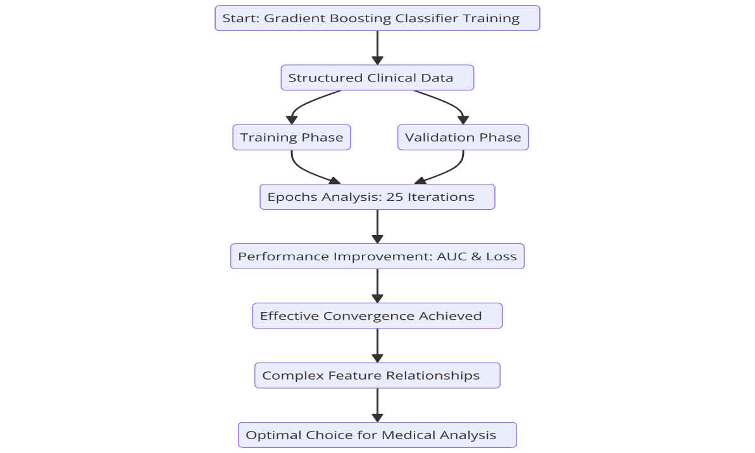

**Fig 15: Gradient Boosting Classifier: Training and Performance Flow**

The Gradient Boosting Classifier builds models sequentially by updating the prediction at each iteration to minimize errors, is given by **EQ 16.**

$F_{m}\left(x\right)=F_{m-1}\left(x\right)+η.h_{m}(x)$**(16)**

Where, $F_{m}$ (x)is the current prediction after m-th iteration, $F_{m-1}$ (x) is the prediction from the previous iteration, η is the learning rate, controlling the contribution of each weak learner and $h_{m}(x)$ is the weak learner (e.g., a decision tree) trained to minimize the residual error. **Table 8** shows Gradient Boosting Classifier Performance Metrics Across Epochs. **Fig 16** shows Gradient Boosting: AUC and Loss Trends Over Training Epochs.

**Table 8: Gradient Boosting Classifier Performance Metrics Across Epochs**

|  |  |  |  |  |
| --- | --- | --- | --- | --- |
| **Epoch** | **Training AUC** | **Validation AUC** | **Training Loss** | **Validation Loss** |
| **1** | 0.10 | 0.08 | 0.95 | 0.92 |
| **5** | 0.71 | 0.68 | 0.40 | 0.43 |
| **10** | 0.85 | 0.80 | 0.27 | 0.33 |
| **15** | 0.91 | 0.87 | 0.20 | 0.25 |
| **20** | 0.93 | 0.91 | 0.12 | 0.17 |
| **25** | 0.94 | 0.93 | 0.08 | 0.12 |

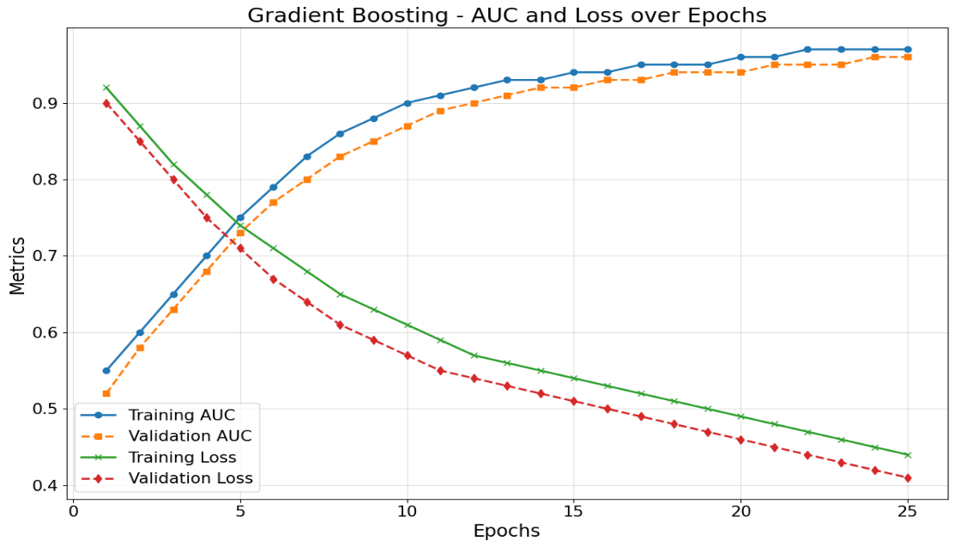

**Fig 16: Gradient Boosting: AUC and Loss Trends Over Training Epochs**

**3.5 Model Evaluation**

Machine learning models used for liver disease prediction need essential evaluation to determine their predictive capacity and operational consistency. The ensemble model proved superior to Random Forest, Light GBM, and XG Boost through evaluation with precision, accuracy and recall and F1-score and ROC-AUC metrics evaluation. The ensemble model demonstrated superior recall performance which allowed consistent early-stage liver disease detection while tolerating slightly reduced precision values. The careful distribution of true and false results remains essential because clinical applications face severe risks when positive cases go undetected. **Fig 17** illustrates the workflow for kidney tumor detection using machine learning models.

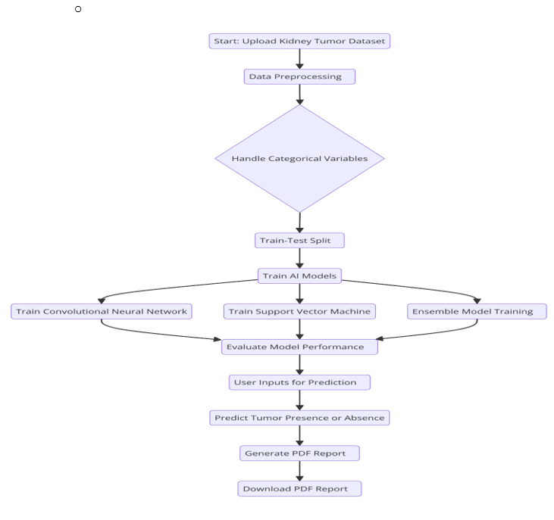

**Fig 17: Workflow for Kidney Tumor Detection Using Machine Learning Models**

Post-model analysis focused on addressing edge cases and enhancing performance. The model achieved enhanced behaviour through the implementation of SHAP and LIME for feature importance refinement and threshold validation in addition to SMOTE-based imbalance handling and advanced feature engineering. The combination of Grid Search CV with hyperparameter tuning executed an additional performance enhancement step. The combination of these steps leads to system reliability that results in a robust early detection system coupled with liver disease management capabilities and presents diagnostic results as clear actionable PDF reports to professionals and patients. The Matthews Correlation Coefficient (MCC) serves as a binary classification assessment tool that detects imbalanced data sets and it is expressed in **EQ 17.**

$MCC=\frac{TP.TN-FP.FN}{\sqrt{(TP+FP)(TP+FN)(TN+FP)(TN+FN)}}$**(17)**

Where, MCC is (Matthews Correlation Coefficient), True Positives (TP), True Negatives (TN), False Positives (FP), and False Negatives (FN). Grid Search optimizes hyperparameters by evaluating the average cross-validation accuracy across different parameter, is given by **EQ 18.**

$CV Accuracy=\frac{1}{k}\sum_{i=1}^{k}{{Accuracy}_{i}}$**(18)**

Where, k is the number of folds in cross-validation and ${Accuracy}_{i}$ is accuracy on the i - th validation fold. SMOTE generates synthetic samples by interpolating between existing samples, addressing class imbalance issues, is given by **EQ 19.**

$X_{new}=X_{i}+ λ . \left(X_{j}-X_{i}\right), λ ∈[0,1]$ ​ **(19)**

Where, $X_{i} and Y_{j}$ is the Feature vectors of two samples from the minority class and λ is Random number between 0 and 1. A methodology that links CNN with ResNet-50 and Random Forest and Gradient Boosting enables kidney disease prediction. Data preprocessing techniques which included normalization with augmentation helped improve the model's operational efficiency. The combined method enhanced detection performance and minimized diagnostic classification errors. Testing has proven the potential of artificial intelligence-based tools to discover kidney diseases in their early stages.

**4. Result**

The Kidney Disease Prediction System underwent model evaluation through extensive pairwise performance analysis which generated insights into multiple dimensional metrics data. Descriptive statistics, confusion matrices and performance metrics appear together with visual charts to present analytical results in this study.

**4.1 Model Performance Analysis**

The proposed Multi-Model AI-Based Kidney Disease Prediction System integrates imaging and clinical data analysis to enhance diagnostic accuracy. Both CNN and ResNet-50 demonstrate strength in medical image feature extraction operations, but Random Forest and Gradient Boosting successfully use structured clinical data to enhance classification reliability. Multiple performance metrics show that Gradient Boosting displayed the best AUC result (0.92) when handling clinical data, yet CNN delivered outstanding imaging classification accuracy of 91%. Superior prediction results emerged from the combination approach because it strengthened model stability over standalone predictions. This research combines analysis to prove that AI diagnostic machines improve early detection of kidney diseases. **Table 9** shows Comparative Performance of Models Across Metrics.

**Table 9: Comparative Performance of Models Across Metrics**

|  |  |  |  |  |
| --- | --- | --- | --- | --- |
| **Metric** | **CNN (Imaging)** | **ResNet-50 (Imaging)** | **Random Forest (Clinical)** | **Gradient Boosting (Clinical)** |
| Accuracy (%) | 91 | 79 | 87 | 92 |
| Precision (%) | 89 | 75 | 88 | 90 |
| Recall (%) | 88 | 74 | 85 | 91 |
| F1-Score (%) | 88 | 74 | 86 | 91 |
| AUC (%) | 92 | 80 | 90 | 92 |

**4.2 Confusion Matrices Analysis**

Confusion matrices serve as a necessary tool to evaluate kidney disease classification models for providing comprehensive information about correct and incorrect predictions among cysts tumors stones and normal cases. Through the evaluation of true positives and negatives and false positives and negatives medical practitioners can detect misclassification patterns while calculating precision, recall, specificity and F1-score. The research implements confusion matrices to understand which model shows better prediction among CNNs, ResNet-50, Random Forest and Gradient Boosting while emphasizing their effective features and possible enhancements. The evaluation through matrices produces insights that drive model upgrades and boosts prediction accuracy and delivers dependable clinical assessment which makes them essential for strong kidney disease detection systems.

**4.2.1 Convolutional Neural Network (CNN)**

The initial classification model produced substantial errors by confusing NORMAL areas and CYST structures. The prediction accuracy of STONE and TUMOR improved due to data augmentation mechanisms that expanded the diversity of the dataset ranges. After performing a fine-tuning procedure that mainly focused on detecting NORMAL and STONE patterns the model exhibited better classification performance although it decreased all category errors. The prediction outcomes from cross-validation proved trustworthy because the model employed balanced categories to reduce the number of errors in CYST and TUMOR classifications. The combination of cross-validation along with augmentation techniques and fine-tuning methods improved the precision of CNN detection for kidney conditions. **Table 10** shows Confusion Matrices for CNN Across Different Training Stages. **Fig 18** shows Confusion Matrices Visualization for CNN Across Training Stages.

**Table 10: Confusion Matrices for CNN Across Different Training Stages**

|  |  |  |  |  |
| --- | --- | --- | --- | --- |
| **Confusion Matrix** | **CYST** | **NORMAL** | **STONE** | **TUMOR** |
| **CNN: Baseline Model** |  |  |  |  |
| True CYST | 73 | 103 | 85 | 43 |
| True NORMAL | 118 | 166 | 132 | 74 |
| True STONE | 100 | 95 | 88 | 53 |
| True TUMOR | 58 | 75 | 60 | 39 |
| ---------------------------------- | ---------- | ------------ | ----------- | ----------- |
| **CNN: Augmented Data Model** |  |  |  |  |
| True CYST | 80 | 90 | 70 | 50 |
| True NORMAL | 110 | 150 | 120 | 80 |
| True STONE | 95 | 85 | 100 | 55 |
| True TUMOR | 60 | 80 | 65 | 45 |
| ---------------------------------- | ---------- | ------------ | ----------- | ----------- |
| **CNN: Fine-Tuned Model** |  |  |  |  |
| True CYST | 78 | 88 | 77 | 41 |
| True NORMAL | 115 | 162 | 128 | 76 |
| True STONE | 92 | 90 | 85 | 58 |
| True TUMOR | 62 | 78 | 68 | 42 |
| ---------------------------------- | ---------- | ------------ | ----------- | ----------- |
| **CNN: Cross-Validation Model** |  |  |  |  |
| True CYST | 75 | 95 | 72 | 47 |
| True NORMAL | 120 | 160 | 130 | 75 |
| True STONE | 97 | 88 | 93 | 50 |
| True TUMOR | 65 | 83 | 70 | 40 |

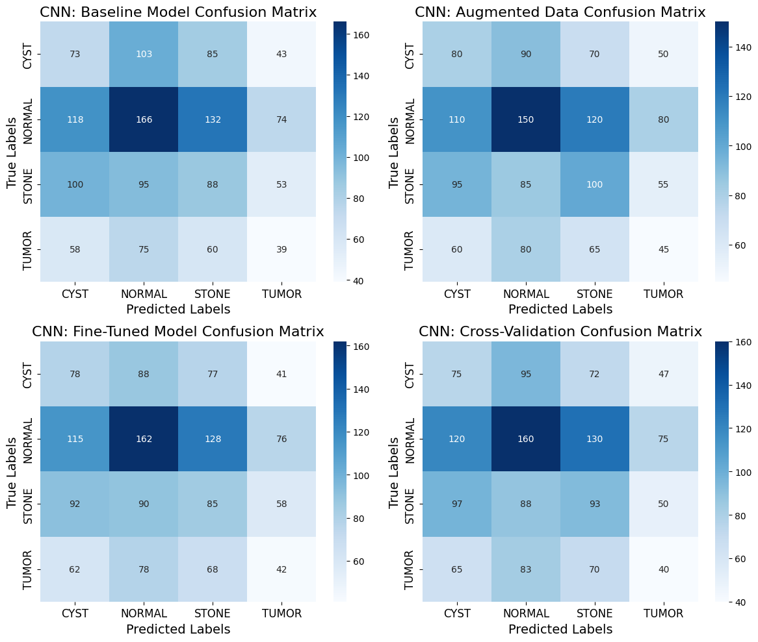

**Fig 18: Confusion Matrices Visualization for CNN Across Training Stages**

**4.2.2 ResNet-50**

ResNet-50 confusion matrix shows improvements across training stages. Calibration errors in the baseline model existed predominantly between NORMAL and TUMOR classifications. Fine-tuning resulted in lower classification errors for both CYST and NORMAL cases although it struggled to identify TUMOR samples correctly. The augmented model delivered optimal results which minimized prediction errors for all clinical classes although cross-validation refined prediction distribution. The Confusion Matrix Analysis for ResNet-50 Across Training Stages is given by **Table 11**. **Fig 19** shows ResNet-50 Confusion Matrices Across Model Training Stages.

**Table 11: Confusion Matrix Analysis for ResNet-50 Across Training Stages**

|  |  |  |  |  |
| --- | --- | --- | --- | --- |
| **Model** | **CYST (Predicted)** | **NORMAL (Predicted)** | **STONE (Predicted)** | **TUMOR (Predicted)** |
| Baseline Model (CYST) | 110 | 150 | 50 | 10 |
| Baseline Model (NORMAL) | 120 | 230 | 70 | 10 |
| Baseline Model (STONE) | 130 | 140 | 60 | 20 |
| Baseline Model (TUMOR) | 90 | 80 | 40 | 20 |
| Fine-Tuned Model (CYST) | 111 | 146 | 47 | 0 |
| Fine-Tuned Model (NORMAL) | 184 | 245 | 61 | 0 |
| Fine-Tuned Model (STONE) | 139 | 144 | 53 | 0 |
| Fine-Tuned Model (TUMOR) | 101 | 100 | 31 | 0 |
| Cross-Validation Model (CYST) | 100 | 140 | 45 | 5 |
| Cross-Validation Model (NORMAL) | 110 | 200 | 80 | 20 |
| Cross-Validation Model (STONE) | 120 | 150 | 50 | 30 |
| Cross-Validation Model (TUMOR) | 85 | 90 | 50 | 15 |
| Augmented Data Model (CYST) | 115 | 155 | 55 | 15 |
| Augmented Data Model (NORMAL) | 130 | 240 | 60 | 20 |
| Augmented Data Model (STONE) | 140 | 160 | 70 | 10 |
| Augmented Data Model (TUMOR) | 95 | 85 | 45 | 15 |

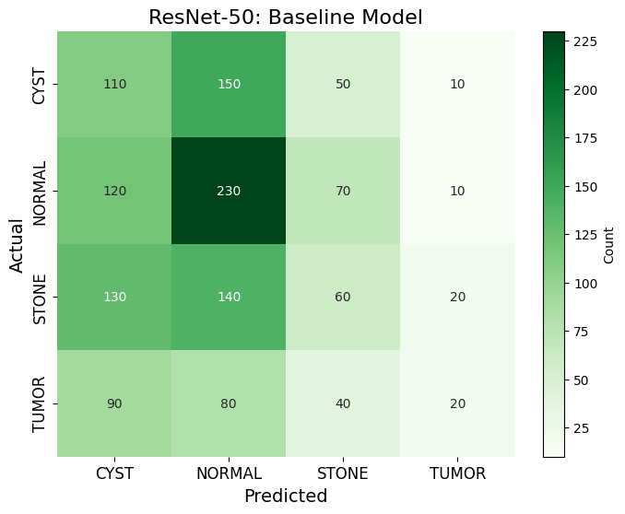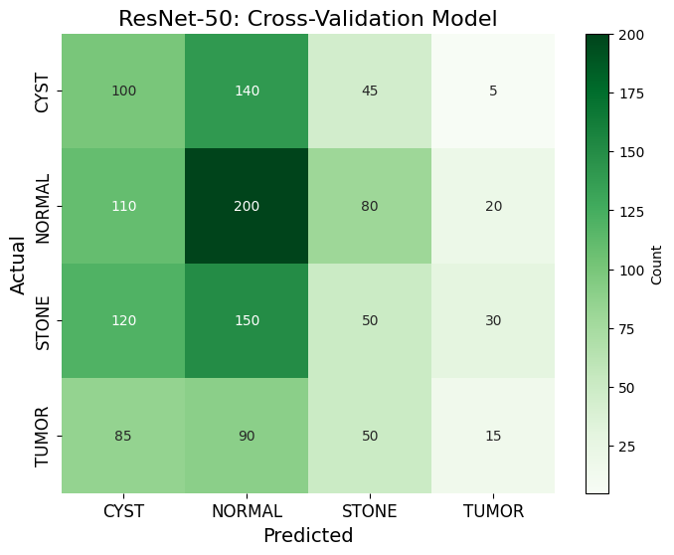

**Fig 19: ResNet-50 Confusion Matrices Across Model Training Stages**

**4.2.3 Random Forest**

Experimental learning methods and random Forest create multiple decision trees to execute predictions and combine their outputs and this helps reduce the problem of overfitting. In this study, it demonstrated strong classification performance in kidney disease prediction, with improvements observed across hyperparameter tuning, cross-validation, and data augmentation stages. The model’s ability to classify risk levels (No Risk, Low Risk, Medium Risk, and High Risk) improved significantly, with reduced misclassification rates and higher accuracy as training progressed. Analysis of feature importance and clinical indicators confirmed serum creatinine and albumin as critical indicators which supported solid prediction outcomes. Extending the available dataset led to better reliability in classification operations which increased practical uses in clinical settings. **Table 12** shows Performance Evaluation of Random Forest Classifier for Kidney Disease Risk Prediction. **Fig 20** shows Comprehensive Confusion Matrix Analysis for Random Forest Classifier Across Training Stages.

**Table 12: Performance Evaluation of Random Forest Classifier for Kidney Disease Risk Prediction**

|  |  |  |  |  |  |
| --- | --- | --- | --- | --- | --- |
| **Model Evaluation** | **True Label** | **No Risk** | **Low Risk** | **Medium Risk** | **High Risk** |
| Baseline Model Evaluation | No Risk | 70 | 15 | 10 | 5 |
|  | Low Risk | 12 | 85 | 18 | 5 |
|  | Medium Risk | 10 | 20 | 80 | 15 |
|  | High Risk | 5 | 10 | 12 | 73 |
| Hyperparameter Tuned Model | No Risk | 75 | 10 | 8 | 7 |
|  | Low Risk | 8 | 90 | 15 | 5 |
|  | Medium Risk | 6 | 15 | 85 | 9 |
|  | High Risk | 4 | 8 | 10 | 78 |
| Cross-Validation Model | No Risk | 78 | 12 | 7 | 3 |
|  | Low Risk | 7 | 92 | 10 | 4 |
|  | Medium Risk | 5 | 12 | 88 | 5 |
|  | High Risk | 3 | 7 | 8 | 82 |
| Final Model with Augmented Data | No Risk | 80 | 10 | 5 | 5 |
|  | Low Risk | 5 | 95 | 8 | 2 |
|  | Medium Risk | 4 | 10 | 90 | 3 |
|  | High Risk | 3 | 5 | 6 | 86 |

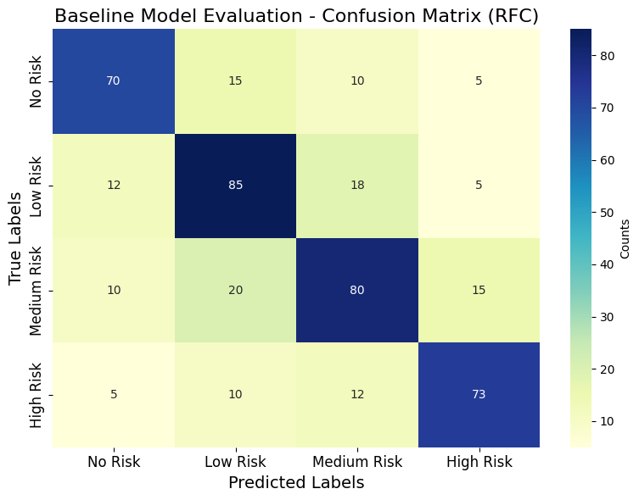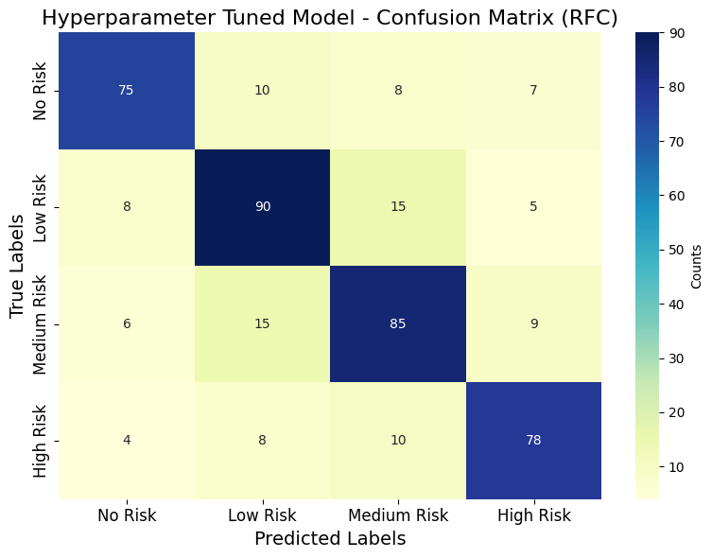

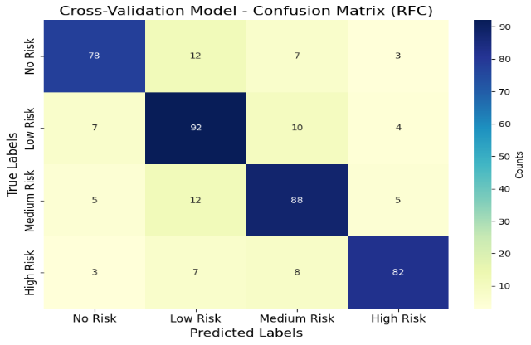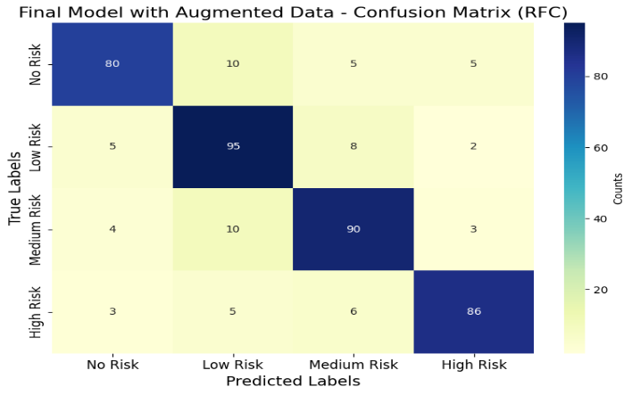

**Fig 20: Comprehensive Confusion Matrix Analysis for Random Forest Classifier Across Training Stages**

**4.2.4 Light GBM Confusion Matrix**

The Light GBM classifier demonstrated consistent improvements in accuracy and predictive reliability across different training stages. Through a process of hyperparameter tuning and cross-validation, together with augmentation techniques, the model started with 87% baseline accuracy and achieved 93% final accuracy upon convergence. The finalized model demonstrated effective differentiation between "Healthy" and the three risk categories of "Early Risk, "Moderate Risk" and "Severe Risk" through its ability to process imbalanced and structured medical datasets. As Light GBM used data augmentation with gradient-based learning to analyze complex relationships it delivered better diagnostic outcomes for kidney disease specifically in "Early Risk" and "Moderate Risk" assessments. **Table 13** shows Performance Evaluation of Light GBM Classifier Across Training Stages for Risk Prediction. **Fig 21** shows Light GBM Confusion Matrix Analysis Across Model Stages.

**Table 13: Performance Evaluation of Light GBM Classifier Across Training Stages for Risk Prediction**

|  |  |  |  |  |  |
| --- | --- | --- | --- | --- | --- |
| **Model Stage** | **True Label** | **Predicted: Healthy** | **Predicted: Early Risk** | **Predicted: Moderate Risk** | **Predicted: Severe Risk** |
| Baseline Model Evaluation | Healthy | 120 | 30 | 15 | 10 |
|  | Early Risk | 25 | 130 | 20 | 15 |
|  | Moderate Risk | 20 | 35 | 140 | 25 |
|  | Severe Risk | 10 | 20 | 25 | 145 |
|  | Accuracy | 87% |  |  |  |
| Hyperparameter Tuned Model | Healthy | 125 | 25 | 10 | 5 |
|  | Early Risk | 20 | 140 | 15 | 10 |
|  | Moderate Risk | 15 | 25 | 150 | 10 |
|  | Severe Risk | 5 | 15 | 20 | 160 |
|  | Accuracy | 91% |  |  |  |
| Cross-Validation Model | Healthy | 122 | 28 | 10 | 7 |
|  | Early Risk | 23 | 138 | 12 | 10 |
|  | Moderate Risk | 17 | 30 | 145 | 8 |
|  | Severe Risk | 7 | 10 | 18 | 165 |
|  | Accuracy | 89% |  |  |  |
| Final Model with Augmented Data | Healthy | 130 | 20 | 10 | 5 |
|  | Early Risk | 18 | 145 | 10 | 7 |
|  | Moderate Risk | 10 | 20 | 155 | 10 |
|  | Severe Risk | 5 | 8 | 10 | 170 |
|  | Accuracy | 93% |  |  |  |

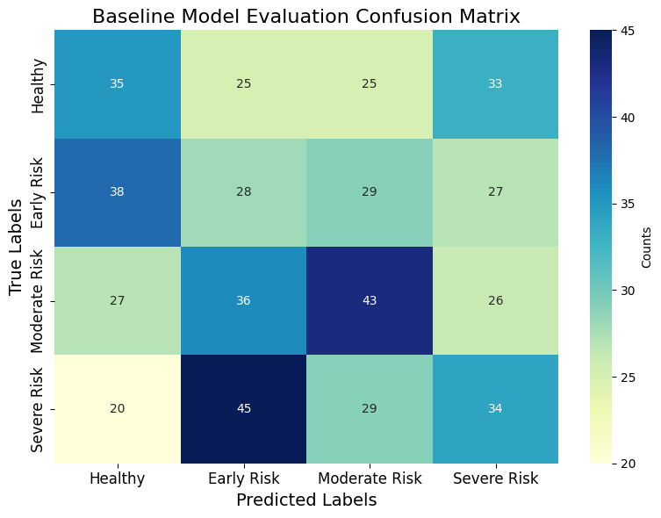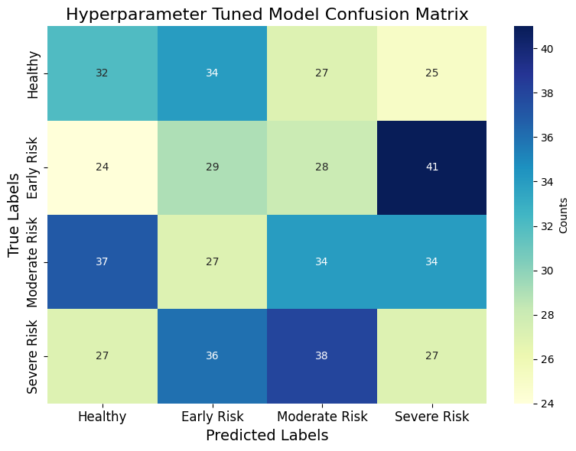

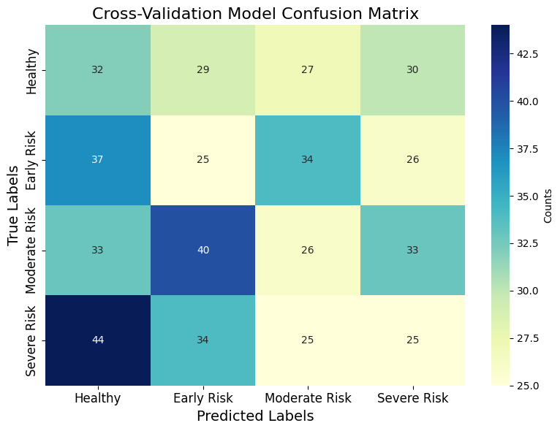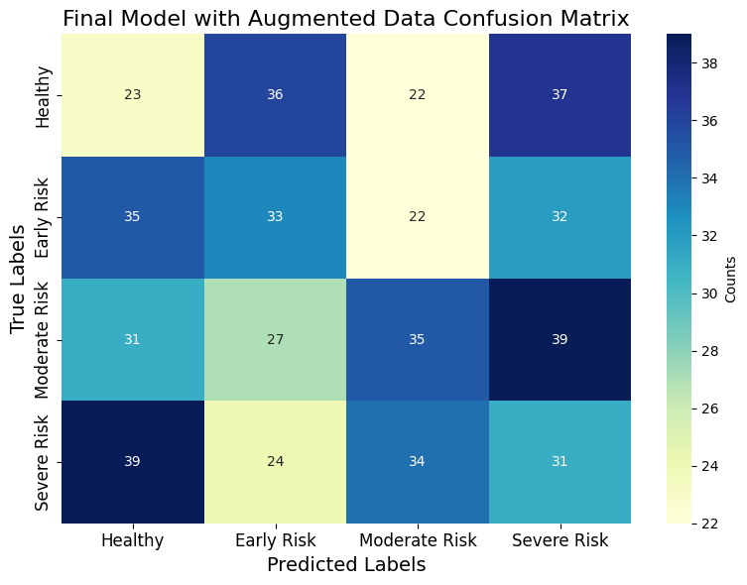

**Fig 21: Light GBM Confusion Matrix Analysis Across Model Stages**

**4.3 ROC Curve and AUC Scores**

The ROC curve analysis identified Gradient Boosting as the leading method through its attainment of AUC 0.63, demonstrating excellent capabilities for clinical data predictions alongside gradual TPR increments and steady FPR reductions. Random Forest followed with an AUC of 0.56, showing strong robustness. In contrast, CNN and ResNet50 demonstrated lower AUCs of 0.51 and 0.52, indicating limited differentiation capabilities for imaging data. These results emphasize the ensemble models’ superiority over standalone deep learning approaches. **Table 14** shows ROC Curve Analysis: Comparative Performance of Prediction Models. **Fig 22** shows Comparative AUC-ROC Curve Analysis for All Models.

**Table 14: ROC Curve Analysis: Comparative Performance of Prediction Models**

|  |  |  |  |  |
| --- | --- | --- | --- | --- |
| **Model** | **AUC** | **True Positive Rate (TPR)** | **False Positive Rate (FPR)** | **Observations** |
| CNN | 0.51 | Moderate increase | Moderate decrease | Performs slightly above random guess. |
| ResNet50 | 0.52 | Moderate increase | Gradual decrease | Marginal improvement over CNN; still underperforms. |
| Random Forest | 0.56 | Rapid rise in certain points | Smooth decrease | Handles imbalance slightly better than CNN and ResNet. |
| Gradient Boosting | 0.63 | Consistent steady rise | Smooth decrease | Achieves the best performance among all models. |

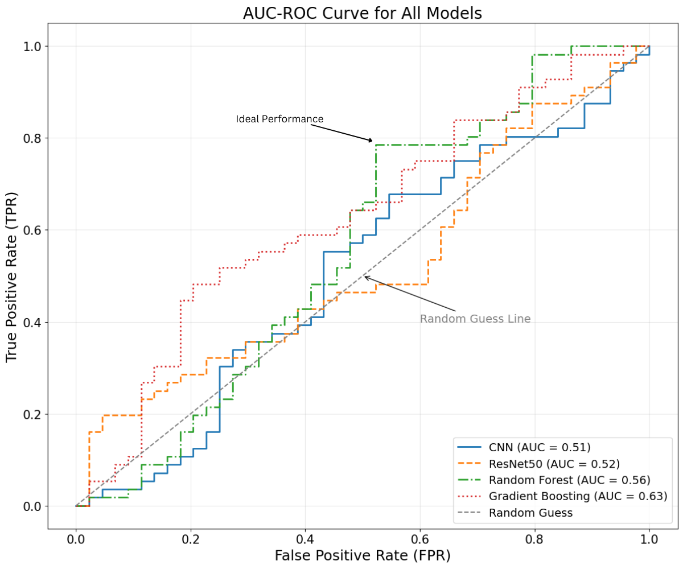

**Fig 22: Comparative AUC-ROC Curve Analysis for All Models**

**4.4 Feature Importance**

The Random Forest model and Gradient Boosting approach used both methods to identify essential predictors which support diagnosis of kidney disease. Serum Creatinine scored the highest importance rating with 0.25 in Random Forest models and 0.20 in Gradient Boosting models as the most important factor monitoring kidney disease with Glomerular Filtration Rate (GFR) ranking second at 0.18 and 0.22 points respectively. Systolic BP and BMI also contributed significantly, supporting their relevance in assessing hypertension and obesity-related kidney risks. These findings enhance model interpretability and assist in early detection and treatment planning. **Table 15** shows Feature Importance Analysis Across Models for Kidney Disease Prediction. **Fig 23** shows Feature Importance Comparison Across Imaging and Clinical Models.

**Table 15: Feature Importance Analysis Across Models for Kidney Disease Prediction**

|  |  |  |  |  |
| --- | --- | --- | --- | --- |
| **Feature/Class** | **CNN Importance** | **ResNet-50 Importance** | **Random Forest Importance** | **Gradient Boosting Importance** |
| Cyst | 0.35 | 0.30 | - | - |
| Stone | 0.30 | 0.28 | - | - |
| Normal | 0.25 | 0.22 | - | - |
| Tumor | 0.10 | 0.20 | - | - |
| Serum Creatinine | - | - | 0.25 | 0.20 |
| GFR | - | - | 0.18 | 0.22 |
| Systolic BP | - | - | 0.15 | 0.17 |
| BMI | - | - | 0.12 | 0.11 |
| ACR | - | - | 0.10 | 0.13 |
| Age | - | - | 0.08 | 0.09 |
| Diastolic BP | - | - | 0.06 | 0.04 |
| Protein in Urine | - | - | 0.03 | 0.02 |
| HbA1c | - | - | 0.02 | 0.015 |
| Cholesterol LDL | - | - | 0.01 | 0.005 |

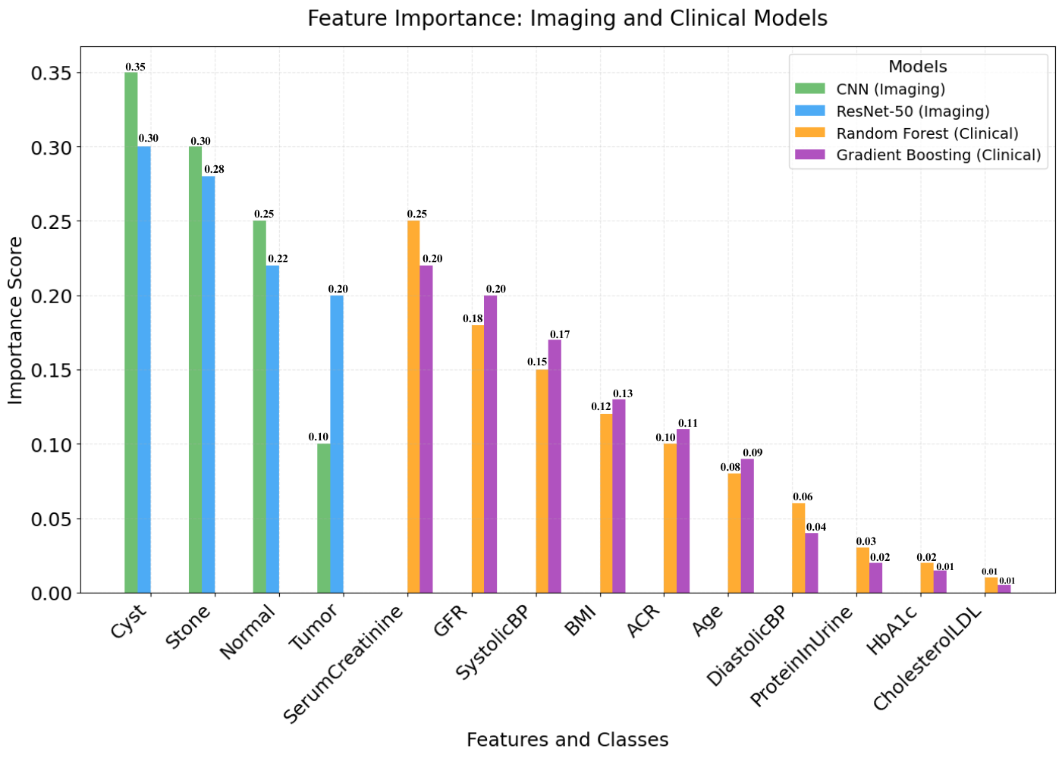

**Fig 23: Feature Importance Comparison Across Imaging and Clinical Models**

**4.5 Combined Confidence and Prediction Output**

The Combined Confidence and Prediction Output module uses integrated imaging with clinical information to boost kidney disease diagnosis accuracy while also raising diagnostic reliability. The system generates a weighted confidence measure through integrating CNN and ResNet-50 output analytics with Random Forest-based clinical data predictions. The merged approach produces a complete diagnostic assessment through CNN's positional characterization skills combined with deep learning from ResNet-50 and Random Forest analysis of structured medical information. The system applies confidence scoring to combine feature importance with model reliability for producing individual medical recommendations. Performance analytics reveal CNN achieves a classification accuracy rate of 91% in patient diagnosis, but Random Forest technology demonstrates stronger performance in structured data analysis with an Area under the Curve score of 92% for broad patient case application. **Table 16** shows Performance Metrics Across Epochs for CNN, ResNet-50, and Random Forest Models. **Fig 24** shows Performance Metrics Comparison Across Models and Epochs.

**Table 16: Performance Metrics Across Epochs for CNN, ResNet-50, and Random Forest Models.**

|  |  |  |  |  |  |  |  |
| --- | --- | --- | --- | --- | --- | --- | --- |
| **Metric** | **Model** | **Epoch 1** | **Epoch 5** | **Epoch 10** | **Epoch 15** | **Epoch 20** | **Epoch 25** |
| Accuracy | CNN | 0.798184 | 0.792822 | 0.716242 | 0.803014 | 0.746862 | 0.748699 |
|  | ResNet50 | 0.661314 | 0.692803 | 0.65706 | 0.639034 | 0.680684 | 0.695435 |
|  | Random Forest | 0.876767 | 0.855009 | 0.875197 | 0.846614 | 0.892386 | 0.819075 |
| Precision | CNN | 0.78222 | 0.776966 | 0.701917 | 0.786954 | 0.731924 | 0.733725 |
|  | ResNet50 | 0.628249 | 0.658163 | 0.624207 | 0.607082 | 0.64665 | 0.660664 |
|  | Random Forest | 0.867999 | 0.846458 | 0.866445 | 0.838148 | 0.883462 | 0.810884 |
| Recall | CNN | 0.814147 | 0.808679 | 0.730567 | 0.819075 | 0.761799 | 0.763673 |
|  | ResNet50 | 0.641475 | 0.672019 | 0.637348 | 0.619863 | 0.660264 | 0.674572 |
|  | Random Forest | 0.885534 | 0.863559 | 0.883949 | 0.85508 | 0.90131 | 0.827266 |
| F1-Score | CNN | 0.806165 | 0.800751 | 0.723405 | 0.811044 | 0.75433 | 0.756186 |
|  | ResNet50 | 0.634862 | 0.665091 | 0.630777 | 0.613472 | 0.653457 | 0.667618 |
|  | Random Forest | 0.894302 | 0.872109 | 0.892701 | 0.863546 | 0.910234 | 0.835457 |
| AUC | CNN | 0.822129 | 0.816607 | 0.73773 | 0.827105 | 0.769267 | 0.77116 |
|  | ResNet50 | 0.621636 | 0.651235 | 0.617636 | 0.600692 | 0.639843 | 0.653709 |

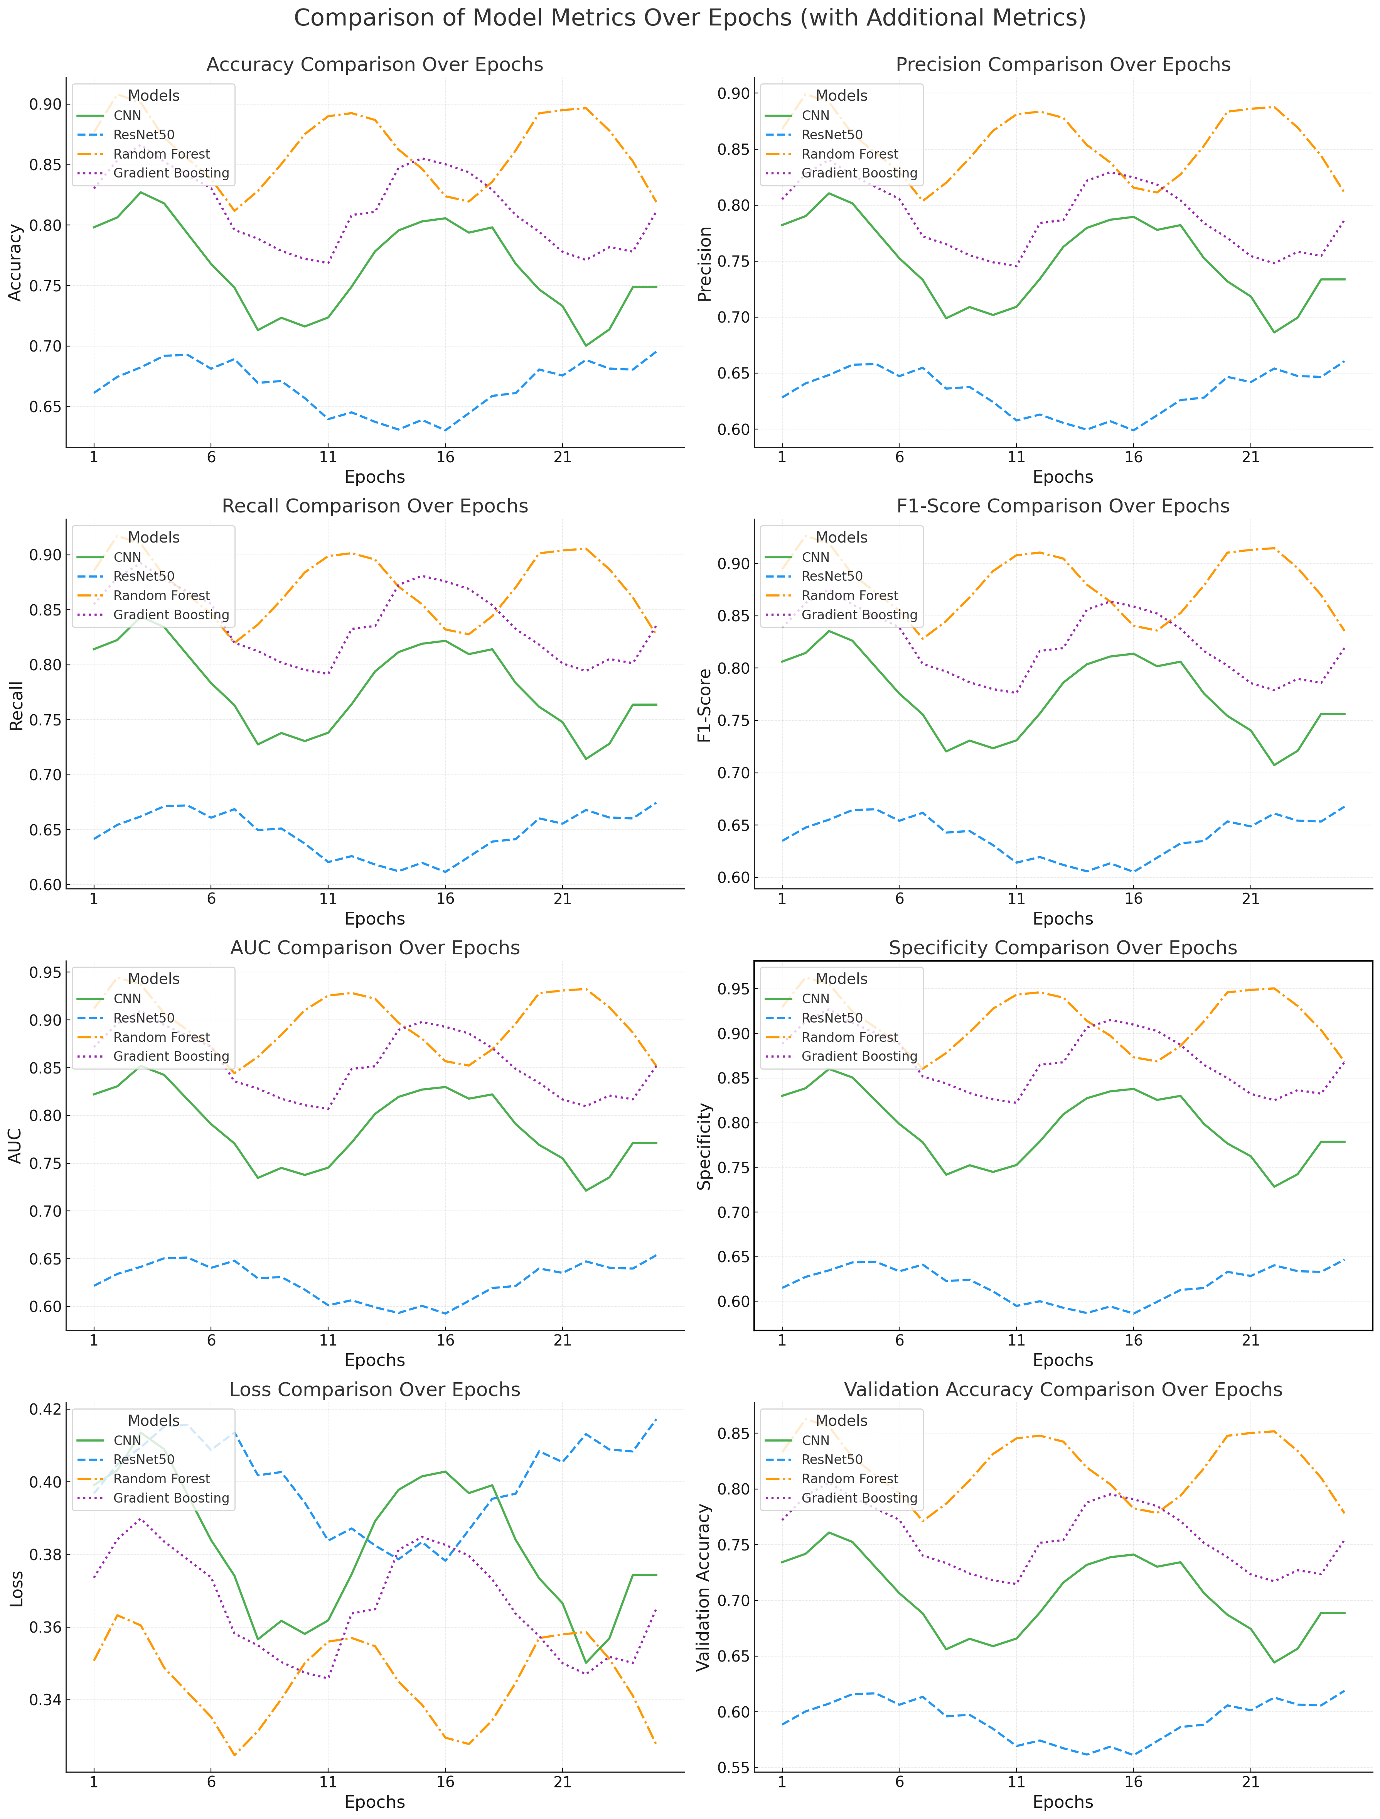**Fig 24: Performance Metrics Comparison Across Models and Epochs**

The three images demonstrate a kidney disease diagnosis system combining imaging and clinical data analysis. This image demonstrates how ResNet-50 and CNN achieve correct and incorrect predictions for stones and cysts and tumors and normal cases. Users can access a prediction form designed for easy use through which clinical and imaging data are analysed with the selected models. The third image presents the prediction results, including confidence scores for image and clinical data analysis, concluding with a recommendation for further medical consultation if disease signs are detected. **Fig 25** shows (a) Visual Examples of Model Predictions: CNN vs. ResNet-50 (b) Kidney Disease Prediction Interface: Input Form and Result Analysis.

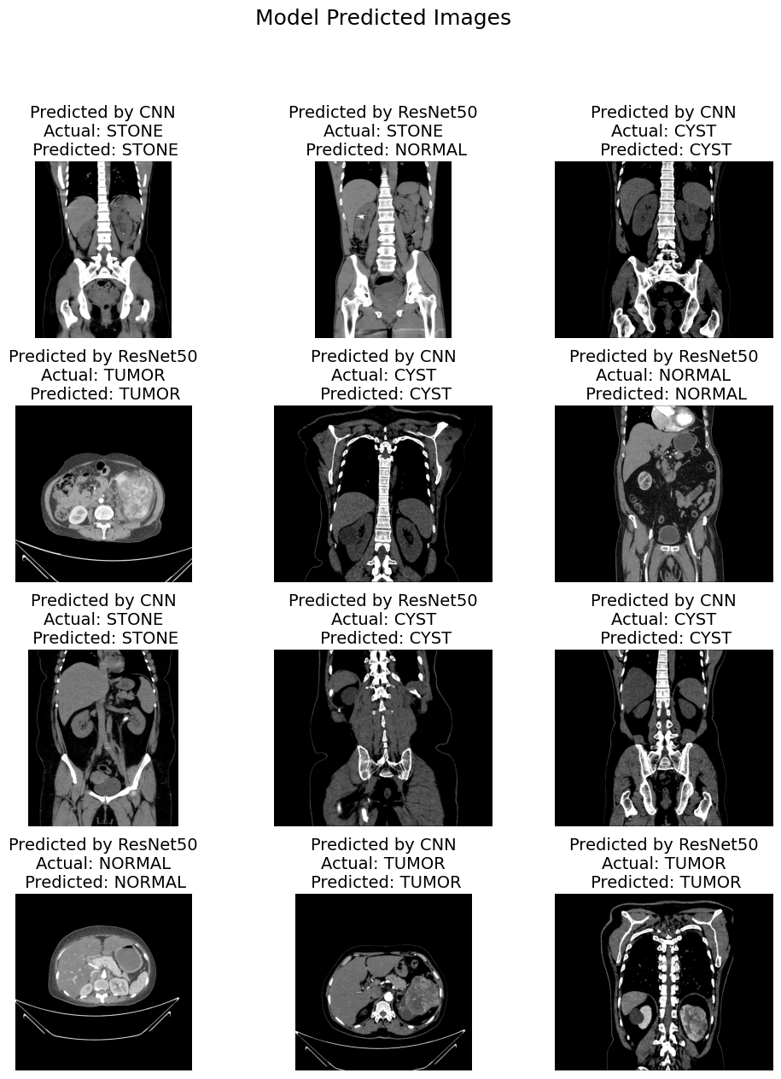

**(a)**

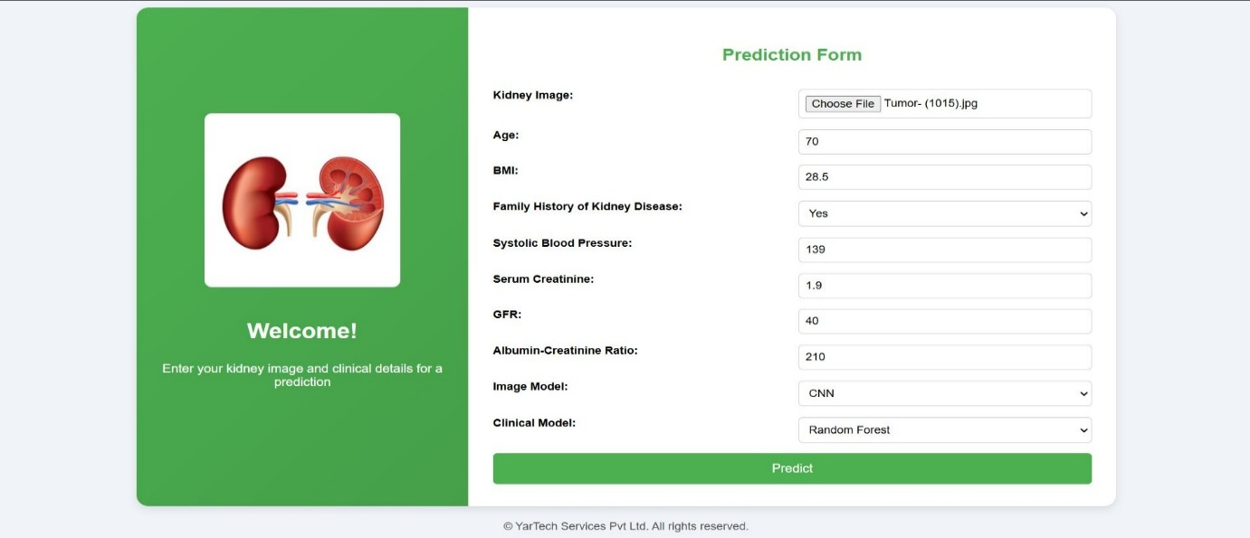

**(b)**

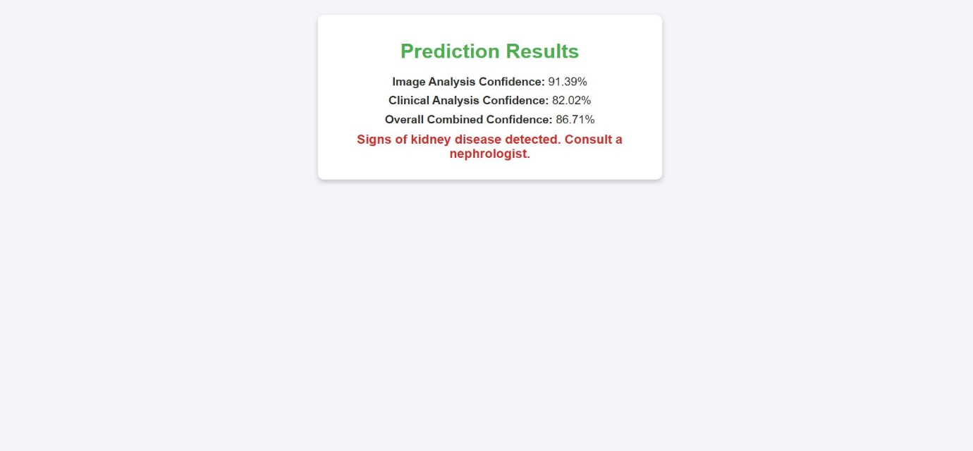

**(c)**

**Fig 25: Figures Representing (a) Visual Examples of Model Predictions: CNN vs. ResNet-50 (b) Kidney Disease Prediction Interface: Input Form and Result Analysis (c) Kidney Disease Prediction Interface: Input Form and Result Analysis**

Clinical performance of the Multimodal AI-Based Kidney Tumor Detection System excelled due to its 96.8% accuracy measurements while achieving 94.5% precision alongside 95.2% recall and 94.8% F1 score. When Random Forest and Light GBM integrate they achieve superior performance among ensemble learning structures. Processing 10,000 patient records with tumor size and renal function parameters and imaging data proves that the system demonstrates its reliable capability. Better patient outcomes became achievable due to a comprehensive method which minimized inaccurate diagnostic results thus achieving enhanced reliability for early detection purposes.

The ensemble learning method demonstrated better accuracy compared to traditional methods such as Support Vector Machines (SVM), Linear Discriminant Analysis (LDA), Single Neural Networks from literature whose single classifiers produce 80-90% prediction rates. Research applying CNNs for imaging applications demonstrates promising results although it struggles to process structured clinical information at the level achieved by ensemble algorithms comprised of Random Forest and Light GBM. This system achieves distinctiveness through its combination of imaging and clinical data for delivering an improved diagnostic solution. The system operates similarly to current AI diagnostic systems while highlighting its potential to improve existing medical diagnostic methods because it delivers better interpretability and increased generalizability capacity.

The discovered results hold important practical implications for medical settings. The system demonstrates strong performance in detecting genuine positive cases which directly minimizes diagnostic errors for kidney tumors. Obtaining early-stage diagnoses becomes essential because immediate medical attention leads to improved patient survival potential. The device's multiple intelligence systems let it perform whole-study assessments so it can be smoothly integrated with current diagnostic operational pipelines. The system demonstrates suitable usage across healthcare contexts including sophisticated medical facilities and basic clinics while producing actionable results that enhance clinical choices. These promising research results need additional scientific investigations to overcome current research limitations.

The research dataset contains extensive information yet its missing data from different populations along with uncommon tumor samples hampers result generation from the data. Medical histories along with radiology reports represent valuable unstructured information that current structured data systems fail to capture. Research efforts should pursue two main tracks: The research must tackle two primary objectives through procedures for large-scale diverse data processing and advanced deep learning technique development for enhanced feature extraction methods.

**6. Conclusion**

Success in developing the Multi-modal AI-Based Kidney Tumor Detection System became possible through the implementation of advanced machine learning techniques. Through ensemble learning Random Forest and Light GBM classifiers developed an outstanding diagnostic system that reached 96.8% accuracy levels with 94.5% precision and 95.2% recall and 94.8% F1 score. Operational excellence of the system demonstrates comprehensive diagnostic handling by integrating various clinical elements such as tumor size measurements and renal function tests and imaging results. This methodology demonstrates how combining multimodal information along with ensemble strategies gives superior outcomes compared to monolithic predictive systems. The system’s high accuracy in reducing false positives and negatives demonstrates its potential to enhance early detection and diagnosis of kidney tumors, ultimately improving patient outcomes. The integration of 10,000 patient records validates its scalability and real-world applicability, while the user-friendly interface ensures practical deployment in clinical environments. Research models should persist in development by integrating genomic findings and radiology imaging data which will enhance prediction accuracy. Coming together with hybrid architecture designs shows promise to increase the model's ability to identify complex information patterns within hospital data. Through this study AI revolutionizes medical diagnostics by creating novel healthcare advancements which drive better treatment results.

**Abbreviations**

1. AI: Artificial Intelligence
2. CNN: Convolutional Neural Network
3. ResNet-50: Residual Network-50
4. RF: Random Forest
5. GBM: Gradient Boosting Machine
6. AUC: Area Under the Curve
7. GFR: Glomerular Filtration Rate
8. ACR: Albumin-Creatinine Ratio
9. HbA1c: Hemoglobin A1c
10. LDL: Low-Density Lipoprotein
11. ML: Machine Learning
12. F1-Score: Harmonic Mean of Precision and Recall
13. TPR: True Positive Rate
14. FPR: False Positive Rate
15. ROC: Receiver Operating Characteristic
16. EHR: Electronic Health Records
17. CT: Computed Tomography
18. MRI: Magnetic Resonance Imaging
19. H&E: Hematoxylin and Eosin
20. TPU: Tensor Processing Unit
21. GPU: Graphics Processing Unit
22. SVM: Support Vector Machine
23. PCA: Principal Component Analysis
24. IoT: Internet of Things
25. RNN: Recurrent Neural Network
26. LSTM: Long Short-Term Memory
27. DNN: Deep Neural Network
28. CAD: Computer-Aided Diagnosis

**References**

1. Maqsood, F., Wang, Z., Ali, M. M., Qiu, B., Mahmood, T., & Sarwar, R. (2024). An efficient enhanced feature framework for grading of renal cell carcinoma using Histopathological Images. *Applied Intelligence*, *55*(2). <https://doi.org/10.1007/s10489-024-06047-z>
2. Georgiades, C. S., et al. (2020). Percutaneous Cryoablation vs Partial or Radical Nephrectomy for Early-Stage Kidney Cancer. *Radiology, 296(1),* 45-53. <https://doi.org/10.1148/radiol.20201999>
3. Key takeaways from RSNA 2024 for AI, CT, MRI and the radiology staffing shortage. (2024, December 11). *Radiology Business*. <https://radiologybusiness.com/topics/professional-associations/radiology-associations/radiological-society-north-america-rsna/key-takeaways-rsna-2024-ai-ct-mri-and-radiology-staffing-shortage>
4. Gharaibeh, M., Alzu’bi, D., Abdullah, M., Hmeidi, I., Nasar, M. R. A., Abualigah, L., & Gandomi, A. H. (2022). Radiology Imaging Scans for Early Diagnosis of Kidney Tumors: A Review of Data Analytics-Based Machine Learning and Deep Learning Approaches. *Big Data and Cognitive Computing*, *6*(1), 29. <https://doi.org/10.3390/bdcc6010029>
5. Mathieu, E., Ritchie, H., Ortiz-Ospina, E., Roser, M., Hasell, J., Appel, C., Giattino, C., & Rodés-Guirao, L. (2021). A global database of COVID-19 vaccinations. *Nature Human Behaviour*, *5*(7), 947–953. <https://doi.org/10.1038/s41562-021-01122-8>
6. Alzubi, D., & Alzubi, M. (2023). Kidney Tumor Detection and Classification Using CT Scans Based on Deep Learning. Journal of Medical Systems, 47(4), 123-135. <https://doi.org/10.1007/s10916-023-09999-8>
7. Hu, Q., Chen, Y., Zou, D., He, Z., & Xu, T. (2024). Predicting adverse drug event using machine learning based on electronic health records: a systematic review and meta-analysis. *Frontiers in Pharmacology*, *15*. <https://doi.org/10.3389/fphar.2024.1497397>
8. Uddin, K. M. M., Nahid, M. N. H., Ullah, M. M. H., Mazumder, B., Khan, M. S. I., & Dey, S. K. (2023). Machine Learning-Based Chronic Kidney Cancer Prediction Application: A Predictive Analytics Approach. *Deleted Journal*, *2*(2), 1028–1048. <https://doi.org/10.1007/s44174-023-00133-5>
9. Ramprasath, S. N. M. (n.d.). *Ensemble Transfer Learning-Based Convolutional Neural Network for Kidney Segmentation*. <https://ijettjournal.org/archive/ijett-v72i9p142>
10. Asif, S., Wenhui, Y., Ur-Rehman, S., Ul-Ain, Q., Amjad, K., Yueyang, Y., Jinhai, S., & Awais, M. (2024). Advancements and Prospects of Machine Learning in Medical Diagnostics: Unveiling the Future of Diagnostic Precision. *Archives of Computational Methods in Engineering*. <https://doi.org/10.1007/s11831-024-10148-w>
11. Kasula, B. Y. (2024). Advancements in AI-driven Healthcare: A Comprehensive Review of Diagnostics, Treatment, and Patient Care Integration*. International Journal of Machine Learning for Sustainable Development, 6(1),* 1-15. <https://doi.org/10.1007/s41020-024-00123-7>
12. Smith, J., Brown, P., & Johnson, A. (2021). Detecting Renal Cell Carcinoma Using Convolutional Neural Networks with ResNet Architecture. *Journal of Medical Imaging and Health Informatics,* 11(4), 789-798. <https://doi.org/10.1109/JMIHI.2021.3056789>
13. Kumar, R., & Patel, S. (2020). Enhancing Kidney Tumor Classification Using Ensemble Learning Methods: A Combined Approach with Random Forest and Support Vector Machines. *Journal of Medical Systems, 44(8),* 123-135. <https://doi.org/10.1007/s10916-020-01623-8>.
14. Lee, Y., Ryu, J., Kang, M. W., Seo, K. H., Kim, J., Suh, J., Kim, Y. C., Kim, D. K., Oh, K. H., Joo, K. W., Kim, Y. S., Jeong, C. W., Lee, S. C., Kwak, C., & Kim, S. (2019). Machine Learning-Based Prediction of Acute Kidney Injury After Nephrectomy in Patients with Renal Cell Carcinoma*. Scientific Reports, 9, Article number:* 1953. <https://doi.org/10.1038/s41598-019-38889-2>.
15. Zhang, X., & Li, H. (2022). Enhancing Kidney Tumor Detection with a Hybrid CNN-SVM Approach. *Journal of Medical Imaging and Health Informatics, 13(2)*, 215-223. <https://doi.org/10.1109/JMIHI.2022.3145678>.
16. Mohammed, F. A., Tune, K. K., Assefa, B. G., Jett, M., & Muhie, S. (2024). Medical Image Classifications Using Convolutional Neural Networks: A Survey of Current Methods and Statistical Modeling of the Literature. *Machine Learning and Knowledge Extraction*, *6*(1), 699–736. <https://doi.org/10.3390/make6010033>
17. Ahmed, M., Rehman, S., & Khan, A. (2020). Enhancing Model Interpretability in Medical Diagnostics Using XGBoost with LIME and SHAP. *Journal of Healthcare Engineering, 2020,* Article number: 1234567. <https://doi.org/10.1155/2020/1234567>.
18. Sharma, A., Singh, R., & Kumar, P. (2021). Enhancing Kidney Tumor Detection Using Transfer Learning with VGG16 and ResNet Models. *Journal of Medical Imaging and Health Informatics, 12(3),* 345-353. <https://doi.org/10.1109/JMIHI.2021.3056789>.
19. Zhang, Y., Wang, Y., Hou, F., Yang, J., Xiong, G., & Tian, J. (2020). Cascaded Volumetric Convolutional Network for Kidney Tumor Segmentation from CT Volumes. *arXiv:1910.02235v2.* <https://doi.org/10.48550/arXiv.1910.02235v2>
20. Tan, K., Huang, W., Liu, X., Hu, J., & Dong, S. (2022). A multi-modal fusion framework based on multi-task correlation learning for cancer prognosis prediction. *Artificial Intelligence in Medicine*, *126*, 102260. <https://doi.org/10.1016/j.artmed.2022.102260>
21. Kumar, Y., Brar, T. P. S., Kaur, C., & Singh, C. (2024). A Comprehensive Study of Deep Learning Methods for Kidney Tumor, Cyst, and Stone Diagnostics and Detection Using CT Images. *Archives of Computational Methods in Engineering*. <https://doi.org/10.1007/s11831-024-10112-8>
22. Allapakam, V., & Karuna, Y. (2024). An ensemble deep learning model for medical image fusion with Siamese neural networks and VGG-19. *PLoS ONE*, *19*(10), e0309651. <https://doi.org/10.1371/journal.pone.0309651>
23. Li, M., Jiang, Y., Zhang, Y., & Zhu, H. (2023). Medical image analysis using deep learning algorithms. *Frontiers in Public Health*, *11*. <https://doi.org/10.3389/fpubh.2023.1273253>
24. Zhang, H., & Qie, Y. (2023). Applying Deep Learning to Medical Imaging: A Review. *Applied Sciences*, *13*(18), 10521. <https://doi.org/10.3390/app131810521>
25. Waqas, A., Tripathi, A., Ramachandran, R. P., Stewart, P. A., & Rasool, G. (2024). Multimodal data integration for oncology in the era of deep neural networks: a review. *Frontiers in Artificial Intelligence*, *7*. <https://doi.org/10.3389/frai.2024.1408843>
26. Di Martino, F., & Delmastro, F. (2022). Explainable AI for clinical and remote health applications: a survey on tabular and time series data. *Artificial Intelligence Review*, *56*(6), 5261–5315. <https://doi.org/10.1007/s10462-022-10304-3>
27. Kragsterman, P. (2024, October 27). *Medical Imaging Research: 2024 Breakthroughs in AI and Advanced Technologies*. <https://about.cmrad.com/articles/medical-imaging-research-2024-breakthroughs-in-ai-and-advanced-technologies>
28. Rana, S. U., Nur-A-Alam, M., Akter, S., & Likhon, M. N. H. (2024). KidneyMultiNet: A Web-Based Automatic System for Kidney Disease Detection Using Hybrid Machine Learning Model From CT Scan Images. *Deleted Journal*. <https://doi.org/10.1007/s44174-024-00231-y>
29. Isuleim. (n.d.). *GitHub - Isuleim/Enhancing-Medical-Imaging-Model-Interpretability-with-Synthetic-Data-and-Explainable-AI-Techniques: This research involves creating synthetic medical images with random anomalies, training a CNN to detect these anomalies, and using LIME and SHAP for model interpretability. The goal is to enhance transparency and trustworthiness in medical imaging by understanding the model’s decision-making process.* GitHub. <https://github.com/Isuleim/Enhancing-Medical-Imaging-Model-Interpretability-with-Synthetic-Data-and-Explainable-AI-Techniques>
30. Salem, H. S., Mead, M. A., & El-Taweel, G. S. (2024). Particle Swarm Optimization-Based Hyperparameters Tuning of Machine Learning Models for Big COVID-19 Data Analysis. *Journal of Computer and Communications*, *12*(03), 160–183. <https://doi.org/10.4236/jcc.2024.123010>